Advisory Bicycle Lanes Research Needs Statement
Title: Advisory Bicycle Lanes – A New Facility for North America Needing Investigation
Background/Description: An advisory bicycle lane (ABL) is a roadway striping configuration which provides for two-way motor vehicle and bicycle traffic using a central travel lane and “advisory” bike lanes on either side. The center lane is dedicated to, and shared by, motorists traveling in both directions. Cyclists are given preference in the bike lanes but motorists can encroach into the bike lanes in order to pass other vehicles after yielding to cyclists.
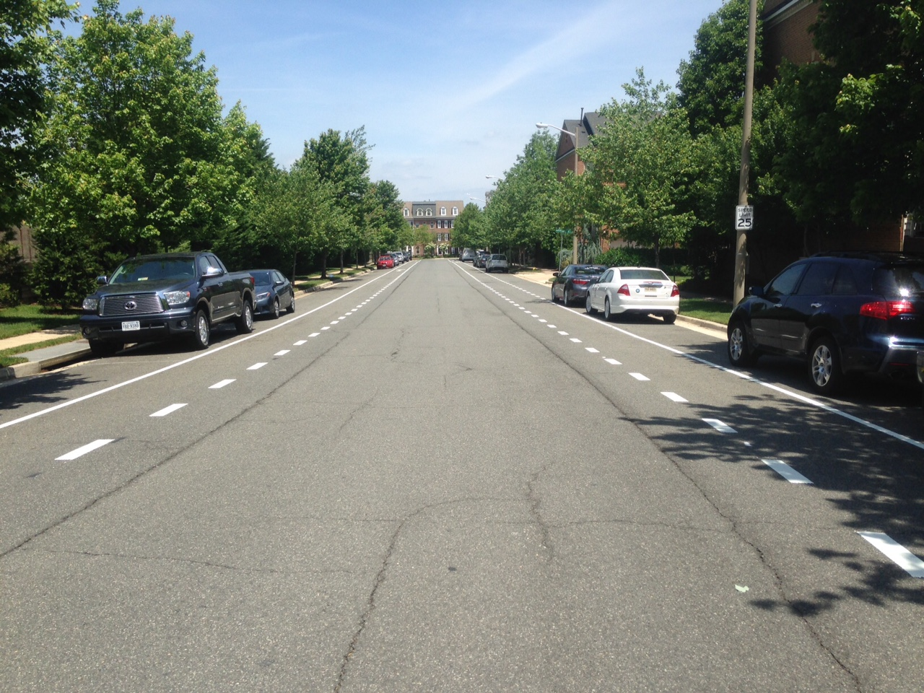
Figure 1 Alexandria, VA Advisory Bike Lane
ABLs are most appropriately sited on low-volume and lower-speed roads.
On low-volume streets without sidewalks, the bike lanes can also function as pedestrian facilities but official acknowledgement of this use requires ADA compliance.
ABLs have the potential to provide thousands of miles of pedestrian and bicycle facilities for just the cost of re-striping. Many rural roads with little chance of receiving funding for widening to support bicycle or pedestrian facilities are candidates. Urban roads on which removal of on-street parking is considered infeasible are candidates. Legacy roads of substandard width are candidates. Any two-way roadway which is currently too narrow for standard bike lanes is a potential candidate for an ABL treatment.
ABLs are being implemented in North America. Nineteen installations were known as of November, 2017 with seventeen in the United States and two in Canada. More facilities are in the design stage. Given the thousands of road-miles which are candidates for an ABL installation, the ABL’s ability to inexpensively provide facilities, and its ability to provide facilities on roads with too little width for standard bike lanes, its continued use and expansion seems likely. Rapid, widespread adoption is a possibility.
Existing North American guidance for this facility consists of two sources: 1) the FWHA Small Town and Rural Multimodal Networks Guide (AKA Small Town Guide) and 2) the FHWA webpage which addresses experimentation with “dashed bicycle lanes”. The webpage provides less guidance and some items conflict with the more recently published Small Town Guide. For this reason, the Small Town Guide is assumed to be pre-eminent.
The Netherlands have thousands of kilometers of ABLs in their country. In their extensive experience, they have found ABLs to be safe and attractive to cyclists when applied within the guidance they have developed for their context. Dutch guidance and research on ABLs has existed since at least 1999.
Areas of Likely Research: There are areas of significant disagreement between American and Dutch guidance. Two specific areas of disagreement produce high priority areas of research for ABLs.
1. Center Lane Width
The Small Town Guide states that a preferred range of center lane width is from 13.5 feet to 16 feet. The 2016 CROW manual states that center lane widths from 12.5 feet to 15.8 feet are prohibited because “it is unclear whether the space is intended for one car or two” which can result in unsafe passing decisions. This center lane width range which may produce uncertainty in drivers’ minds, is the range in which five of twelve recently reviewed ABL installations fell. In addition, wide center lanes may engender higher vehicular speeds. These two effects may produce ABLs which are less safe.
2. Sight Distance
The recommended sight distance criterion for ABLs in the Small Town Guide is the use of Passing Sight Distance (PSD). The use of PSD has a number of problems. First, PSD assumes roadway operations in which opposing traffic occupies their own travel lanes. Second, the assumption made by PSD on speed differential assumes a vehicle-vehicle passing maneuver; the speed differential for a vehicle-bicycle passing maneuver is likely much higher. Third, PSD assumes both vehicles are nineteen feet long which is unlikely in a vehicle-bicycle passing maneuver. PSD is inapplicable to an ABL. A new sight distance model is required.
Other areas needing investigation include:
- Issues arising from use as a pedestrian facility e.g. ADA compliance, safety as compared to standard striping treatments, guidelines for appropriate siting and design of ABLs intended for pedestrian use,
- Intersection treatments for ABLs,
- Values of speed, volume, and other characteristics which characterize a good ABL site,
- How ABLs compare to other facilities suitable for low-volume, low-speed streets,
- Channelizing islands, used in other countries to persuade drivers to return to the center lane and as traffic calming,
- Impact of color in the bike lanes of ABLs, and
- Need for public education and measures which aid driver comprehensibility.
Objective: The proposed research will develop a set of guidelines for appropriate ABL design and facility selection.
The research will consist of the following tasks:
- Review of current guidance, practice and concerns - A comprehensive review of the international and domestic literature focusing on advisory bicycle lanes, one-way roads supporting two-way traffic, and roads lacking centerlines will be conducted. This will include published design guidance. In addition to a literature review, outreach to North American and Dutch agency representatives will be conducted to assess existing installations, their characteristics and any lessons learned from those installations. This information will be used to summarize the state of current research on ABLs, summarize current design practices, and discuss the relationship of this information to the North American context as it relates to ABLs.
- Identify and prioritize critical issues for ABLs - Based on the results of the literature review and synthesis of practice, the research will identify and prioritize the most critical design and operational issues for which guidance is needed.
- Evaluate possibility of retrospective and/or prospective studies - Look at the population of existing installations and available data for those facilities to assess the possibility of including this data. Assess the creation of a study protocol which the FHWA could make available through the request-to-experiment process so that future studies are more rigorous and comparable.
- Design a simulator-based experiment – Simulator testing provides well-controlled conditions and the opportunity to interview drivers about their experience. This perspective will be important to assess the impact of center lane width on choices around speed and vehicle-vehicle passing maneuvers. Simulators will also be used to test features which are inaccessible or non-existent. These include channelizing islands, intersection treatments, or colored bike lanes.
- Design a field-based data collection experiment - Working from the list of prioritized issues, a field-based observational experiment will be designed. The experiment design will address as many critical issues as feasible. In addition, methods to capture a range of conditions (e.g., center lane width, heavy vehicle %, posted speed limit, etc.) will be explored and data collection locations proposed.
- Collect and analyze data - Implement the data collection program and analyze the results to draw lessons on suitable design guidance and street characteristics for ABLs.
- Develop and publish ABL guidelines - The final product of the research will be a user-friendly set of guidelines for the selection and design of ABLs. The guidelines will be research-based, practical, and applicable to practitioners operating in a wide range of contexts.
Potential Benefits: ABLs have the potential to cheaply and safely provide bicycle facilities on many thousands of miles of roads in the United States. Proper facility selection and design guidance is critical to creating ABLs which are safe and comfortable. This research will move guidance on these facilities forward by creating guidance based on research and laying the groundwork for collection of more data to guide future implementations.
Related Research: The only domestic research that exists on this facility consists of evaluation reports of installed facilities in Boulder, CO, Edina, MN, Hanover, NH, Minneapolis, MN. These reports were required as part of the FHWA experimentation process.
Implementation: The product of this research would guide communities in choosing appropriate streets, choosing amongst possible facility types and designing safe and comfortable ABL facilities.
Funding (choose one of the following): >$300k
Research Period (choose one): 12 to 24 months
Research Priority (choose one): This research is considered high priority given the ABL’s ability to inexpensively provide bicycle facilities on thousands of road-miles, the uptick in its adoption rate and its potential to spread rapidly.
Source Information (Committee members, workshops, conferences): FHWA Small Town and Rural Multimodal Networks Guide, Lessons Learned: Advisory Bicycle Lanes in North America, AASHTO Guidelines for Geometric Design of Very Low-volume Local Roads, 2016 CROW manual.
RNS Developer: Michael Williams
Sponsoring Committee: ANF20

