FY2021 NCHRP PROBLEM STATEMENT

# PROBLEM TITLE

Edge Lane Roads: Operations and Safety in Rural and Urban Areas

# BACKGROUND

More than 2 million paved road-miles in the US are classified as local and collector roads. The work to add sidewalks and/or bicycle facilities to these roads would cost billions of dollars and require decades. Because of their lower speeds and volumes, these roads can be good sites for on-street bicycle and pedestrian facilities.

A new road configuration known as an Edge Lane Road (ELR), which encompasses “Advisory Bike Lanes” and “Advisory Shoulders”, addresses cost, timeframe and width issues by providing an on-street space preferentially reserved for bicyclists, pedestrians, and other vulnerable road users (VRUs) within the confines of a standard 2-lane road with only the cost of re-striping and some signage.

An ELR is a roadway which supports two-way motor vehicle and vulnerable road user travel with a center lane and edge lanes on either side. The bidirectional center lane is dedicated to motor vehicles. The unidirectional edge lanes support VRUs, such as cyclists or pedestrians. Motor vehicles may use the edge lanes, after yielding to any VRUs there, to pass oncoming vehicles.



Figure 2 When two MVs meet, they can use the edge lanes to pass.

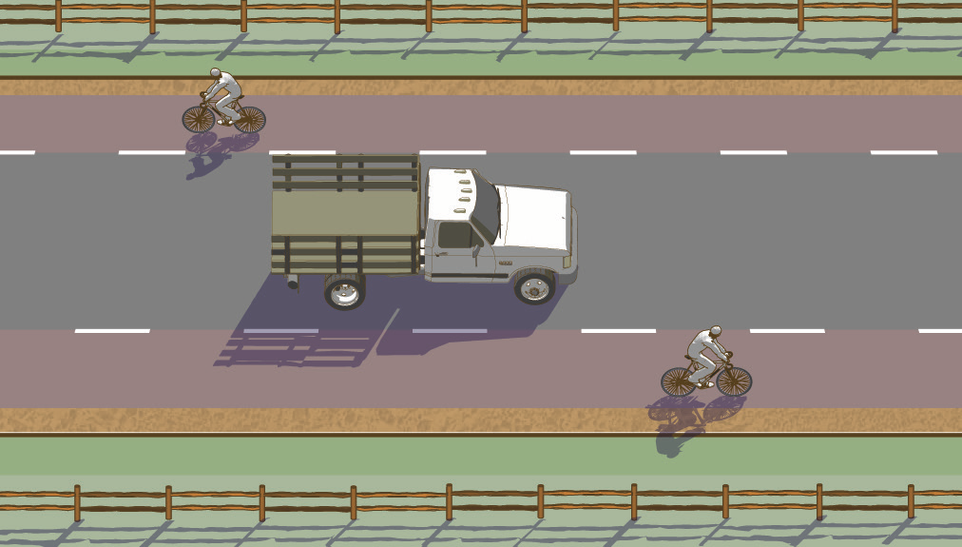

Figure 1 MVs travel in the center lane. When passing VRUs, no lane change is needed.

A 2013 survey of 21 developed countries showed over half used ELRs. The Netherlands has used this format for more than 50 years and has installed over 1,000 road-kilometers.[1] North America has over 30 installations as of September, 2019.[2] They are safe and effective.[3]

A new direction of research is the potential use of ELRs to improve motorist safety on rural low-volume, high-speed roads. These roads are home to more than half of the crash fatalities in the US[4] and single-vehicle, roadway-departure crashes make up more than half of all rural road crashes[5]. Rates for this crash type drop significantly when wider shoulders are provided[6][7][8]. By placing motorists in the middle of a road, ELRs create wide shoulders without expensive widening. Examples of these roads already exist internationally. See <https://www.advisorybikelanes.com/rural-abl-project.html> for more information.

# LITERATURE SEARCH SUMMARY

The existing domestic research consists of evaluation reports of North American facilities and papers found at <https://www.advisorybikelanes.com/more-info.html>.

Other domestic literature includes the FHWA Small Town and Rural Multimodal Networks Guide, the ABL Design Guide at <https://www.advisorybikelanes.com/design-guidance.html>, and the AASHTO Guidelines for Geometric Design of Very Low-volume Local Roads. Numerous international sources exist but are too numerous to list or summarize here.

# RESEARCH OBJECTIVE

The objective of this research is to:

* Determine optimal lane widths for this road format,
* Assess the safety of edge lane roads in the North American context,
* Develop an appropriate sight distance for edge lane roads,
* Evaluate the impact of siting factors including roadway contexts, speeds, volumes, heavy vehicle percentage and other characteristics,
* Evaluate the possible use of ELRs on rural low-volume, high-speed roads, and

**The final product would be guidance and recommendations for the use of edge lane roads in North America.**

***Task 1: Generate a Literature Review and Synthesis of Practice -***This task will produce a summary of current research, current design practices, and lessons learned from agencies using ELRs.

***Task 2: Identify and prioritize critical issues for ELRs*** *-* Based on the results of the literature review and synthesis of practice, the research will identify and prioritize the most critical design and operational issues, if they differ from the prioritized list provided above.

***Task 3: Evaluate possibility of retrospective and/or prospective studies –*** Data on existing installations will be evaluated to assess the value of including it. A protocol would be created for prospective studies and would be shared through the FHWA Request-To-Experiment process and used for future North American installations.

***Task 4: Design a simulator-based experiment –*** Simulators provide well-controlled conditions and the opportunity to interview drivers about their experience. This perspective will be important to assess the impact of center lane width on choices around speed and passing maneuvers. Simulators can be used to test inaccessible or non-existent features such as channelizing islands, intersection treatments, or colored edge lanes. Newer bicycle simulators may be used to obtain input from bicyclists on various configurations as well.

***Task 5: Design a field-based data collection experiment -*** A field observation experiment will address as many critical issues as feasible. Methods to capture a range of conditions (e.g., center lane width, heavy vehicle %, posted speed limit, etc.) will be explored and data collection locations proposed.

***Task 6: Collect and analyze data*** *-* Implement the data collection program and analyze the results to draw lessons on suitable design guidance and street characteristics for ELRs.

***Task 7: Develop and publish ELR guidelines*** - The final product will be a user-friendly set of guidelines for ELR implementation. The guidelines will be useful to practitioners operating in a wide range of contexts.

# URGENCY AND POTENTIAL BENEFITS

This research addresses two major questions with which state DOTs are currently struggling. ELRs provide facilities for VRUs on millions of miles of paved roads in the United States. They may also reduce the rate of single-vehicle, roadway departure crashes on millions of miles of low-volume, high-speed rural roads by inexpensively creating wide shoulders.

If this research is not conducted, the rapidly increasing rollout of this new road format will continue forward without sufficient knowledge to ensure safe roads.

This research will support the ability of jurisdictions to inexpensively provide facilities for VRUs on roads unlikely to receive facilities for years or decades. It may also help address the fatality rate on 2-lane rural roads.

# IMPLEMENTATION CONSIDERATIONS AND SUPPORTERS

* State DOT engineers responsible for road design could use these results to improve safety and provide facilities for VRUs. State DOTs which provide local assistance can use these results when helping smaller agencies with road design issues.
* Little to no work would be required for state DOTs to use this research. ELRs would become part of their toolbox for the problems described herein and these results would accurately guide use of ELRs.
* Support of implementation would be accomplished via training venues (webinars, conference presentations, etc). Data on future installations would be gathered and assessed via research publications to continue refining ELR use.
* Awareness is one of the largest hurdles for ELRs and their appropriate use. Training, conference presentations, webinars, etc will address this problem.
* The AASHTO Joint Technical Committee on Non-Motorized Transportation recently requested a research needs statement on this topic. The RNS provided to that committee makes up the bulk of this problem statement. The contact there is Ken Brubaker of Colorado DOT, 303-757-9804, [kenneth.brubaker@state.co.us](mailto:kenneth.brubaker@state.co.us). ANF20, the TRB Bicycle Transportation Committee has adopted an RNS on edge lane roads with the co-sponsorship of AFB10 Geometric Design Committee. The contact there is Krista Nordback of the Highway Safety Research Center at The University of North Carolina, 919-962-3493, nordback@hsrc.unc.edu.

# RECOMMENDED RESEARCH FUNDING AND RESEARCH PERIOD

Recommended Funding: $600,000

Research Period: 30 months

# PROBLEM STATEMENT AUTHOR

Michael Williams, Michael Williams Company, 530-859-3468, bikepedx@gmail.com

# OTHERS SUPPORTING THE PROBLEM STATEMENT

TRB ANF20 Bicycle Transportation Committee, TRB AFB10 Geometric Design Committee (as described above).

# POTENTIAL PANEL MEMBERS

Michael Williams Company, Michael Williams, 530-859-3468, [bikepedx@gmail.com](mailto:bikepedx@gmail.com); Cal Poly San Luis Obispo, Dr. Anurag Pande, 805-756-2104, [apande@calpoly.edu](mailto:apande@calpoly.edu); Harvard University, Dr. Carole Voulgaris, 617-475-0461, [cvoulgaris@gsd.harvard.edu](mailto:cvoulgaris@gsd.harvard.edu)

# PERSON SUBMITTING THE PROBLEM STATEMENT

Jonathan Howard, 805-549-3111, [jonathan.w.howard@comcast.net](mailto:jonathan.w.howard@comcast.net), California Department of Transportation

1. OECD/International Transport Forum (2013), *Cycling, Health and Safety*, OECD Publishing/ITF. http://dx.doi.org/10.1787/9789282105955-en
2. <https://www.advisorybikelanes.com/more-info.html>, List of North American ABLs
3. <https://www.advisorybikelanes.com/more-info.html>, Draft ITE Journal article titled “An Update on ABLs”
4. <https://safety.fhwa.dot.gov/local_rural/>, Accessed September 11, 2019.
5. NCHRP Report 362 Roadway Widths for Low-Traffic-Volume Roads, 1994, Transportation Research Board.
6. CMF ID 5285, <http://www.cmfclearinghouse.org/detail.cfm?facid=5285>, Accessed September 11,2019
7. Zegeer, C.V. et al. Safety Effects of Cross-Section Design for Two-Lane Roads. Report No. FHWA-RD-87/008., FHWA and TRB, Washington, DC, October, 1987.
8. Griffin LI, Mak KK. Benefits to be achieved from widening rural, two-lane, farm-to-market roads in Texas. National Research Council, Transportation Research Board; 1988.