Edge Lane Roads

Current Status and Future Possibilities
Edge lane roads (ELRs) are more commonly known as Advisory Bike Lanes, when they are intended to support bicyclists, or Advisory Shoulders when they are intended to support pedestrians. ELRs are defined as a road consisting of a single center lane which supports two-way motor vehicle travel and an edge lane on either side, preferentially reserved for one-way use by vulnerable road users. ELRs are not marked with a center line and the edge lanes are delineated by broken lines as described in “Chapter 3D Markings for Preferential Lanes “of the MUTCD. Motorists travel in the center lane as shown in the left of Image 1 until they need to pass an approaching vehicle. In order to pass, they merge into the edge lanes after yielding to any users already present as shown in the right of Image 1. After completing the passing movement, motorists return to the center lane.
ELRs provide facilities for vulnerable road users on lower-volume streets. These facilities are not exclusive nor protected but are useful in many situations.
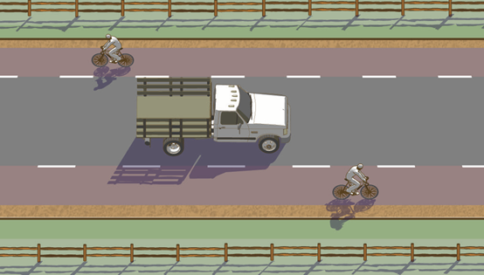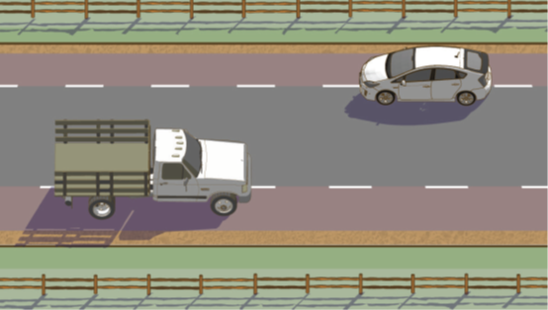
Image 1: ELR Operation from the FHWA Small Town and Rural Multimodal Networks Guide
This article looks at the current state of ELRs in North America, draws some conclusions about their feasibility, and examines their future prospects. All data presented without reference has been obtained through interviews with representatives of the responsible agencies.

Progress in guidance and regulatory arenas
ELRs are currently classified as an experimental treatment by the FHWA. The FHWA recommends use of the Request to Experiment (RTE) process for new ELRs.
ELRs first appeared in official North American design guidance in the December, 2016 FHWA Small Town and Rural Multimodal Networks Guide.
The Bicycle Technical Committee of the National Committee for Uniform Traffic Control Devices convened a task force in January, 2019 to recommend changes to the MUTCD to support Advisory Bike Lanes. When these changes will appear in the MUTCD is unknown.
The FHWA included Advisory Bike Lanes in their Bikeway Selection Guide published in February, 2019.
The next release of the AASHTO Bike Guide includes this treatment.

Overview of installed ELRs
As of September, 2019, at least thirty ELRs had been installed in the U.S. and Canada. Because some ELRs were discovered only by chance, the true number may be higher. This number does not include variants which possess only one edge lane or use non-standard pavement markings.
Two of the ELRs for which data is included below were removed after installation – Wooddale Avenue in Edina, MN and Irving Street in Cambridge, MA. The Edina facility was removed because of public opposition, likely due to the lack of public outreach and education prior to its installation. The Cambridge facility was removed due to resident complaints of increased horn use which was assumed to indicate that some motorists believed the street to be one way only and honked at motorists traveling in the opposite direction.
The information presented below include data from six ELRs in Minneapolis, MN. This skews the data towards that city’s approach to ELR design and use. Minneapolis, MN plans to have eight ELRs installed by the end of 2019, the most of any city in the U.S. or Canada.

Installations
Despite widespread use in other countries for decades, ELRs are new to the US and Canada. The first North American ELR is considered to be East 14th Street in Minneapolis, MN which was installed in September, 2011. Figure 1 shows the installation of ELRs over the last few years. Data for 2019 only includes the first five months.

Figure 1 ELR Installations over Time

Speed Limits
Most ELRs outside Minnesota are posted at 25 MPH. All of the 30 MPH ELRs are located in Minnesota which has statutory speed limits of 30 MPH on these types of streets. ELRs with multiple speed limits were included at the highest speed limit allowed. The ELR in Ottawa, ON is posted at 40 km/h and is included in the data as 25 MPH. Guidance allows ELRs to be used on streets with speeds up to 35 MPH but no ELRs above 30 MPH or 40 km/h are known.

Figure 2 ELR Speed Limits

Motor Vehicle Volumes
Vehicular volumes range from approximately 200 ADT to more than 5,000 ADT. Some of the ADT numbers provided below are estimates provided by city staff or calculated from peak hour volumes. ELRs with multiple counts available were included at the highest measured volume. Guidance allows ELRs to be placed on streets with up to 6,000 ADT.
This graph shows the use of ELRs at vehicular volumes approaching the 6,000 ADT limit.

Figure 3 ELR Traffic Volumes

Lengths
All existing North American ELRs are less than one mile long. The most frequent role of an ELR is as a short connector between other pedestrian or bicycle facilities within a city’s network. This is a result of one of their major advantages – the ability to provide facilities where sidewalks or standard bicycle lanes are not feasible due to lack of width. The very short ELR listed for Yarmouth, ME consists of an installation over a bridge which lacks sidewalks.

Figure 4 ELR Lengths

Lane Widths
The selection of lane widths for an ELR is an under-appreciated process. The choices for lane widths are significant and will not be deeply explored in this article. Briefly, Dutch and Danish research show that some center lane widths can result in a less safe ELR. This range of center lane widths is referred to as the “ambiguous zone” because it produces uncertainty in the motorist’s mind whether the edge lane is needed when passing an approaching vehicle. The Small Town and Rural Multimodal Networks guide recommends center lane widths which fall within this ambiguous zone but the current draft of the upcoming AASHTO Bike Guide revises that recommendation. More information on this issue is available in the ABL Design Guide available at https://www.advisorybikelanes.com/design-guidance.html.
Figure 5 shows total ELR widths by summing twice the edge lane width and the center lane width. This shows how width was allocated in each installation. Where lane widths varied, the maximum values were used.

Figure 5 ELR Lane Widths
Underlying this lane width data are a combination of two inaccurate perceptions of ELRs. The first is the street width on which they are applicable and the second is referred to by me as the “Five-Foot-Bike-Lane” mindset.
The total width of most ELRs lies at or below thirty feet. The thirty foot upper limit results from the belief that standard bike lanes are always preferable to ELRs. A road width of thirty feet is the minimum needed for a common configuration of two 10’ travel lanes and two 5’ bicycle lanes. Beyond this width, most communities choose bicycle lanes. This incorrect belief is addressed later in the article.
The “Five-Foot-Bike-Lane” mindset results in ELR designs with five foot wide edge lanes and the remainder of the street width allocated to the center lane. Because the entire road remains available to motorists, this approach is misguided. The opposite approach is more suitable, i.e. provide sufficient room for safe travel in the edge lanes first, with the remaining width used for the vehicular center lane. This provides the opportunity to create edge lanes wide enough to safely support side-by-side riding, bicycle-bicycle passing and bicycle-pedestrian passing. Narrow center lanes also have the potential to induce traffic calming.

Use of the FHWA Request to Experiment Process
Of the sixteen independent U.S. agencies which have installed ELRs, seven chose not to use the FHWA RTE process. Reasons for not using the RTE process vary. Some states have sovereign immunity laws which protect local agencies from legal attack; this nullifies the greatest benefit of an approved RTE application. Some agencies were unaware of the RTE process or the experimental status of ELRs.
The lack of awareness of the RTE process and ELR’s experimental status may point to a need for more education in this area. The lack of data from ELRs installed outside the RTE process is unfortunate.
A number of conversations with individuals across the nation have described significant resistance to the ELR concept because of its experimental status. Unfortunately, no data is available on the safety costs of facilities which are not installed.

Safety
Six North American installations have been studied and have results which are publicly available. Some of these evaluations are final reports required under the FHWA Request To Experiment process. A summary of these studies is shown in Table 1.
Generally, following the installation of an ELR the studies found:
- a reduction or no change in crash rate,
- a reduction or no change in motor vehicle speed,
- a reduction or no change motor vehicle volume, and
- mixed results with respect to bicycle volume changes.
All of the agencies responsible for these studies concluded that the ELRs were safe and operating as intended. The five studies which evaluated horizontal distance between motor vehicles and bicycles saw excellent results with all, or an overwhelming majority of, passing movements demonstrating distances of more than three feet.
The most notable result of this collection of studies is the absence of problems which many fear when they consider the use of ELRs. These studies document no head-on vehicle collisions and no safety problems due to a misunderstanding of the road’s operation.

ELR Study | Post-ELR Changes
 | Vehicle Speed | Vehicle Volume | Bicycle Volume | Crash Rate
Harvard Lane  Boulder, CO | None | Decrease  ? | Decrease  ? | None
Lakeview Avenue  Cambridge, MA | None | None | - | -
West 54th Street  Edina, MN | 1-3 MPH reduction | - | - | None
Valley Road  Hanover, NH | - | Decrease  ? | Increase  ? | None
Grant St/14th Street East  Minneapolis, MN | None | Mixed  ? | Mixed  ? | Decrease
Somerset Street East  Ottawa, ON | 5.2% reduction | - | - | -
‘?’ = Unclear if changes were statistically significant
‘-’ = Study did not address this issue or complete data was not available
Table 1 Summary of ELR Evaluation Studies
If one multiplies each ELR’s number of service days by its ADT and sums over all of the ELRs, we generate an estimate of 80.5 million vehicle trips on ELRs as of May 31, 2019. The lack of safety issues across a base of this size, with 60,000 vehicle trips being added every day, is a positive sign that this road format works as well in North America as it does elsewhere in the world.

Future Application of ELRs
At this point, ELRs are primarily applied on streets too narrow for standard bike lanes in urban and suburban areas. But ELRs contain the potential to provide benefits in other settings.

An Alternative to Door-Zone-Bicycle-Lanes
The view of ELRs as a mechanism for providing bicycle facilities only when road width is insufficient for standard bike lanes is inaccurate. In some situations, ELRs can provide greater horizontal separation between bicyclists and vehicles than standard bicycle lanes.
The accepted practice of placing standard bicycle lanes on roads between on-street parking and vehicle travel lanes provides little margin for error when vehicle doors, pedestrians, garbage cans, etc, occlude the bike lane and force cyclists into the travel lane. These are often referred to as door-zone-bicycle-lanes (DZBL) because an opened vehicle door can result in injury or death for bicyclists. In terms of horizontal separation, ELRs provide a superior alternative to DZBLs on two-lane roads with appropriate width, volumes and speeds.
As an illustration, consider a road with parking lanes on both sides of the street and 32 feet of available width between parking lanes. This road would normally be configured with 11' travel and 5' bicycle lanes or 10' travel and 6' bicycle lanes. Figures 6 and 7 show this road configured with standard bicycle lanes and as an ELR. If the street was configured as an ELR, one could provide a 3' wide hatched area next to the parking lanes (to mark the door zone and reserve a place for pedestrians, garbage cans, etc.), 8’ wide edge lanes, and a 10' center lane. The ELR configuration provides an additional five feet of clearance between moving motor vehicles and bicyclists, it provides an area reserved for streetside activities (pedestrians accessing parked vehicles, garbage cans, etc), eliminates the dooring hazard, and provides an edge lane wide enough for side-by-side riding and comfortable bicycle-bicycle passing movements. In this case, an ELR provides greater separation for all road users than do standard bicycle lanes. Greater separation reduces stress, improves safety, and results in lower scores on the Level of Traffic Stress (LTS) scale.

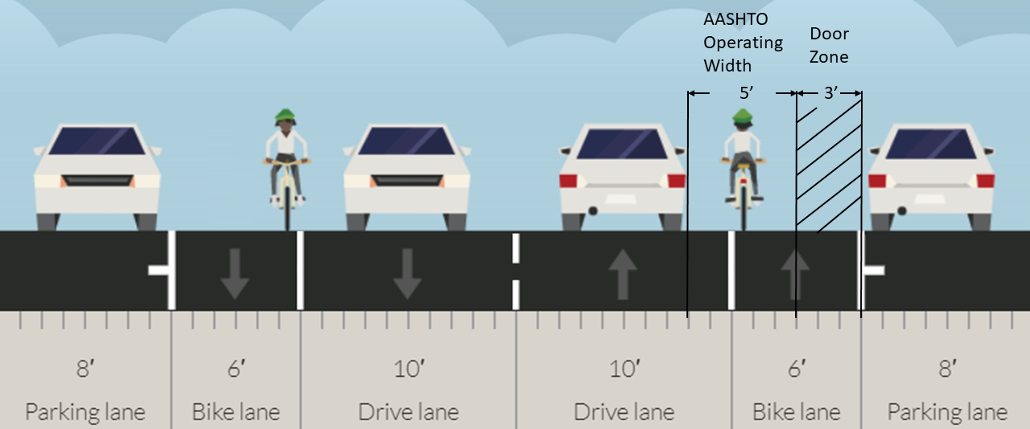
Figure 6. Door-Zone-Bicycle-Lane
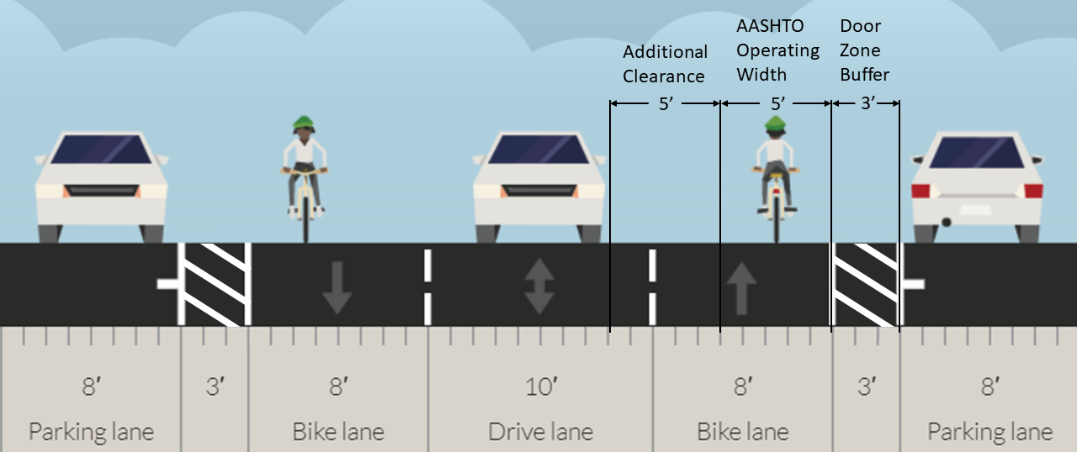
Figure 7. Edge Lane Road

Rural Road Safety Improvements
ELRs have the potential to reduce the crash rate on low-volume rural roads with speeds above 35 MPH even where bicycle and pedestrian facilities are a low priority. Rural roads are home to more than half of the crash fatalities in the US and single-vehicle, roadway departure crashes make up more than half of all rural road crashes. The rate of roadway departure crashes drops significantly when wider shoulders are provided. Conversion of narrow, two-lane roads to ELRs provides wide shoulders at little cost which may significantly decrease the crash rates on these roads. High-speed, low-volume rural roads configured as ELRs are already successfully used in Great Britain and Australia. The application of ELRs to this domain will be examined in research slated to begin later this year by the author. More information on this concept is available at www.advisorybikelanes.com/rural-abl-project.html.

Conclusion
ELRs continue to gain acceptance and credibility in North America. All studies to date have shown them to be safe and effective at achieving their goals while maintaining or improving safety. In some situations ELRs are arguably superior to standard bicycle lanes. With their low cost and ability to provide space for vulnerable road users, their use is likely to grow.
Those interested in learning more about ELRs should visit www.advisorybikelanes.com. Subscribing to the ELR email listserve at https://lists.coe.neu.edu/cgi-bin/mailman/listinfo/advisorybikelanes is a good way to keep abreast of new developments. If you know of an ELR that isn’t listed in this article, please let the author know at bikepedx@gmail.com.

https://www.advisorybikelanes.com/more-info.html, List of North American ABLs, Accessed September 11, 2019
OECD/International Transport Forum (2013), Cycling, Health and Safety, OECD Publishing/ITF. http://dx.doi.org/10.1787/9789282105955-en
"FHWA Right to Experiment Final Report" Memo, City of Boulder, June 13, 2016, David Kemp.
"Lakeview Avenue Advisory Bicycle Lane Assessment" Memo, City of Cambridge, December, 2016, Jerry Friedman.
"FHWA Request to Experiment 2014 Final Evaluation Report", City of Edina, December 31, 2014.
"Summary of Valley Road Advisory Lanes: A Case Study in Hanover, New Hampshire", E. Wygonik, B. Young, P. Kulbacki, C. Radisch.
"Valley Road Advisory Lanes: A Case Study in Hanover, New Hampshire", E. Wygonik, 2017 TRB Presentation."
"Advisory Lanes", September 19, 2016 Memo from Peter Kulbacki, Director of Public Works to Select Board
"Evaluation of Bicycle Traffic Control Devices and Street Design Elements in Minneapolis, Chapter 7", City of Minneapolis, March 13, 2017
"Operational Evaluation of Advisory Bike Lane Treatment On Road User Behavior In Ottawa Canada", Ali Kassim, City of Ottawa
“A Comparison of Advisory Bike Lanes to Bicycle Boulevards, Bicycle Lanes, and Yield Roadways using Level of Traffic Stress – An Application of LTS to ABLs”, https://www.advisorybikelanes.com/uploads/1/0/5/7/105743465/an_application_of_lts_to_abls.docx, May 15, 2019
https://safety.fhwa.dot.gov/local_rural/, Accessed September 11, 2019.
NCHRP Report 362 Roadway Widths for Low-Traffic-Volume Roads, 1994, Transportation Research Board.
CMF ID 5285, http://www.cmfclearinghouse.org/detail.cfm?facid=5285, Accessed September 11,2019
Zegeer, C.V. et al. Safety Effects of Cross-Section Design for Two-Lane Roads. Report No. FHWA-RD-87/008., FHWA and TRB, Washington, DC, October, 1987.
Griffin LI, Mak KK. Benefits to be achieved from widening rural, two-lane, farm-to-market roads in Texas. National Research Council, Transportation Research Board; 1988.
https://www.advisorybikelanes.com/rural-abl-project.html, Accessed September 11, 2019

