Licensed drivers were presented with a side showing the view of an Advisory Bike Lane with an approaching vehicle alone with an image of a modified W1-4 sign. Participants were asked “Imagine you are driving along the roadway and encounter this sign. What does this sign mean?” They were then shown the sign and then the sign was removed.
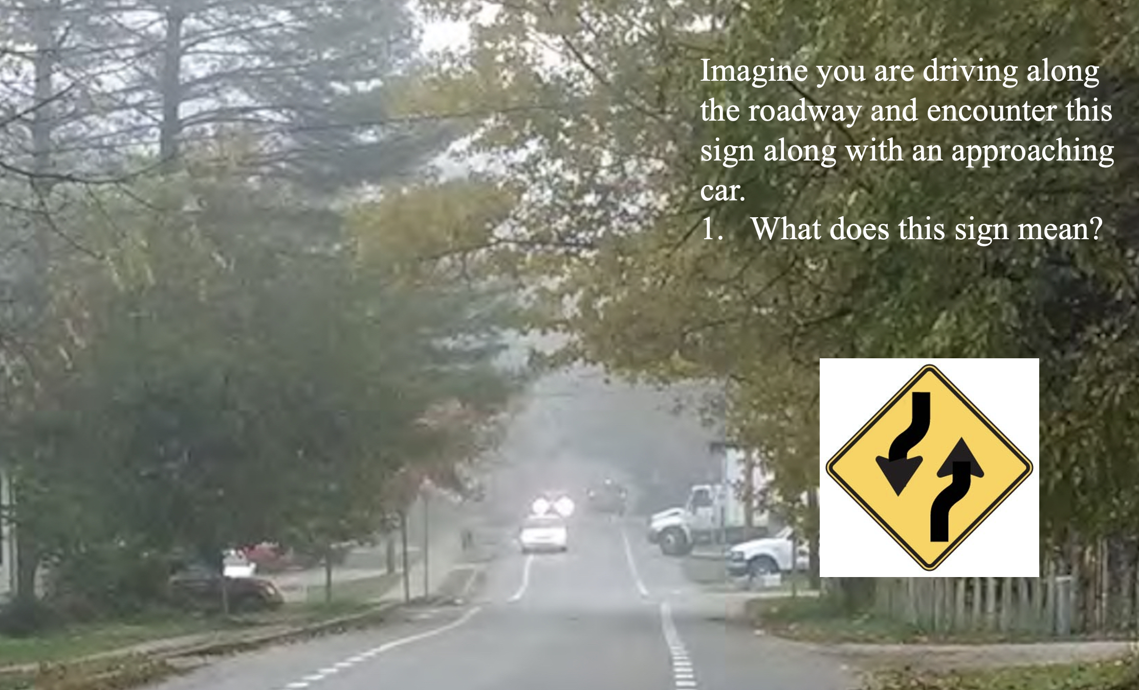

All respondents were undergraduate university students. Results are presented in Table 1. Responses were placed into categories which included all the responses. For example the category: I should move to the right included statements like “Move to the right to pass”, or “Move over to pass.” Respondents that said “Use caution to pass” or “Take turns passing” did not mention move to the side but it is possible that they would have indicated that if directly asked how they would pass. 15 respondents who said move to the right or move over to pass also mentioned bicyclist. The subset also said they could move into the bike lane to pass or could not move into the bike lane are also indicated in the last two columns.

Table 1. The percentage of participant responses within each coded category for each alternative.
 | I should move to the side | Use Caution Passing | Take Turns Passing | Lanes Curve Ahead | Subset That Said Move to Side You Can Go in Bike Lane | Subset That Said Move to Side You Can’t Go in Bike Lane
Number of Responses | 100 | 2 | 9 | 10 | 11 | 4
Percentage of Responses | 82.3 | 1.7 | 7.4 | 8.3 | 11% of Those Who Understood Sign | 4% Who Those Who Understood Sign

