Road Diet
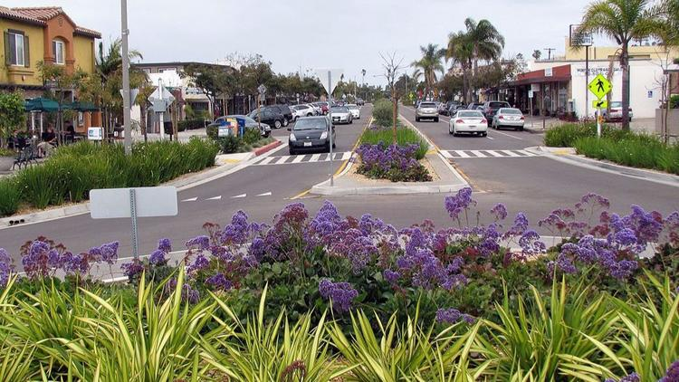_________Plus

TABLE OF CONTENTS

TABLE OF CONTENTS 2
Introduction to the Road Diet Plus 3
Background 1
Purpose & Organization of document 3
Why Consider a Road Diet Plus? 4
Benefits 4
Tradeoffs 9
Feasibility Determination 11
Design of a Road Diet Plus 21
Assessment of a Road Diet Plus 22
Conclusion 23
References 25
Appendix A LA JOLLA BOULEVARD TRAFFIC DATA 27
Appendix B LA JOLLA BOULEVARD PEDESTRIAN AND BICYCLE DATA 29
Appendix C ROUNDABOUT CHARACTERISTICS 31

Cover Photo courtesy Dan Burden & San Diego Union Tribune

Introduction to the Road Diet Plus
According to the 2014 FHWA Road Diet Informational Guide (Knapp, 2014), a road diet is generally described as “removing travel lanes from a roadway and utilizing the space for other uses and travel modes.” This term is most often used to refer to the conversion of a four-lane undivided roadway to a 3-lane undivided roadway consisting of two through lanes on either side of a two-way left turn lane (TWLTL).
As reported in the Road Diet Informational Guide (Knapp, 2014), experience with the standard road diet shows many benefits of the three lane over the four lane undivided configuration. These include:
- A 19 to 47 percent reduction in overall crashes
- A reduction in speed differential which reduces crash severity
- A reduction in various types of delay
- Right of way available for reallocation to pedestrian and bicycle facilities
- Risk reduction for pedestrians whether crossing at an intersection or mid-block
- An improvement of the livability or comfort level of the street
But what is required to go one step, or one lane, further? Is it possible to reduce the street cross-section by another lane? Assuming that street performance is adequate for all travel modes, removing another lane would be expected to increase the benefits conferred by the standard road diet along with the boon of additional liberated right-of-way.
This guide describes the conversion of a four- or five-lane corridor to a two-lane street with roundabouts at all intersections and a raised median along the length of the corridor segments. The use of roundabouts as intersection treatments allows all mid-block left turning movements to be converted into U-turns at the roundabouts followed by right turns at the destination. Roundabouts allow the TWLTL to be removed from the three lane configuration.
This conversion is called a Road Diet Plus. This conversion can have benefits that go beyond the standard road diet. They include:
- An increase in segment safety due to the elimination of all mid-block left turns
- A large increase in intersection safety due to the use of roundabouts
- A corridor-wide reduction in peak speeds
- A corridor-wide increase in throughput and average speed
- An increase in available right of way for multimodal improvements
- A decrease in risk for pedestrians and bicyclists
- An increase in the livability and comfort of the street environment
This guide will explore the benefits and tradeoffs of the Road Diet Plus and attempt to characterize the traffic characteristics within which this conversion can be successful. This guide uses the 2014 FHWA Road Diet Informational Guide as a conceptual base and assumes a level of familiarity with that document by the reader.
There are many factors to consider when evaluating the possibility of a Road Diet Plus. It is not possible to exhaustively list and circumscribe all of the factors needed for a successful conversion. This document chooses to examine only vehicle throughput and right-of-way available at the intersections as primary evaluation factors.

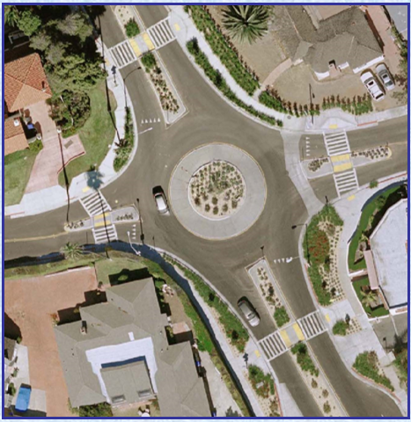
Figure 1: La Jolla Boulevard (Courtesy City of San Diego)

Background
The Road Diet Plus is the result of a synthesis of three recent trends in American traffic engineering. Those trends are road diets, the advantages and growing acceptance of roundabouts, and the more recent use of roundabouts as a tool for corridor renovation.
In 1999, Dan Burden and Peter Lagerwey published an article titled “Road Diets: Fixing the Big Roads” (Burden, 1999). This article documented the early stirrings of the road diet movement and provided details on a number of successful road diets across the nation. These road diets removed lanes from overbuilt streets. In the process of doing so, they created streets which were much safer, more livable, more multimodal, and just as effective at carrying motor vehicle traffic. One notable example described was the ability of a three lane road, Lake Washington Boulevard in Kirkland, WA, to successfully carry 30,000 ADT.
In 2011, Nikiforos Stamatiadis et al of the Kentucky Transportation Center, published a report titled “Guidelines for Road Diet Conversions” (Stamatiadis, 2011). The report was intended to create a guide for road diets which included feasibility determination and design suggestions. They evaluated both simulation results and actual conversions. Their conclusion was that the upper traffic volume limit for a successful road diet could be as high as 23,000 ADT. They also emphasized the importance of traffic signals as a consideration when evaluating feasibility since, in many cases, intersection layout and signal timing were the chief obstacles to a successful road diet.
In 2014, the FHWA published an informational guide on road diets titled “Road Diet Informational Guide” (Knapp, 2014). Its purposes were the same as Stamatiadis’ publication but it presented lower upper volume limits than the 23,000 ADT suggested by Stamatiadis. Since its publishing, this guide has served as a summary of current state-of-the-art for road diets. Because it is frequently referenced, this work will refer to it as the RDG.
These three documents portray the growth of the road diet concept into a well-studied tool available to traffic engineers everywhere.
The installation of modern roundabouts in the United States was another trend that started to gain prominence in the 1990’s. A significant body of work, both in the literature and on-the-ground, demonstrated the overwhelming safety benefits of roundabouts and their performance advantages over other intersection treatments. FHWA RD-00-067 titled “Roundabouts: An Informational Guide” published in 2000 (FHWA, 2000), NCHRP Report 572 titled “Roundabouts in the United States” published in 2007 (Rodegerdts L. B., 2007), and NCHRP Report 672 titled “Roundabouts: An Informational Guide” published in 2010 (Rodegerdts L. B., 2010) document the rising interest in, and popularity of, roundabouts across the nation.
In response to the growing use of multiple roundabouts in a corridor setting, NCHRP Report 772 titled “Evaluating the Performance of Corridors with Roundabouts” was published in 2014 (Rodegerdts L. J., 2014). This work accomplished a number of important goals but one of the most important was demonstrating that the throughput advantages of roundabouts in isolation transferred well to a corridor setting.
The Road Diet Plus concept sits at the confluence of these three trends. This guide describes a Road Diet Plus, provides a process for determining the feasibility of its application, and describes one successful execution.

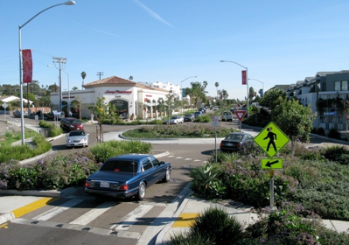
Figure 2: La Jolla Boulevard & Midway Street (Courtesy City of San Diego)

Purpose & Organization of document
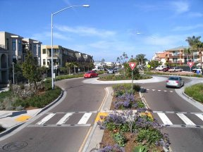
This guide will provide information on the safety benefits and trade-offs of this conversion. This guide will provide feasibility, design and effectiveness information for those wishing to know more about the potential of this conversion.
The primary objective of this guide is to provide a process for determining the feasibility of applying a Road Diet Plus to a particular corridor.
Figure 3: La Jolla Boulevard (Courtesy San Diego Union-Tribune)
The structure of this guide mirrors the structure of the RDG and is organized into the following sections:
- Why Consider a Road Diet Plus?
- Feasibility Determination
- Design of a Road Diet Plus
- Assessment of a Road Diet Plus
- Conclusion

Why Consider a Road Diet Plus?
With the increased focus on safety, livable streets, and the provision of all ages and abilities facilities for bicyclists, the Road Diet Plus should be of great interest to those seeking safer, more comfortable streets. In addition, slower-than-expected growth in motor vehicle use, greater use of public transit and over-built legacy streets combine to provide opportunities for its application. Below are some of the benefits and trade-offs to a Road Diet Plus conversion.

Benefits

Roundabouts
A standard road diet normally changes existing traffic control at intersections only to the extent needed to accommodate the new lane layout. Corridors composed of a four or five lane street with various sizes of minor streets use signalization, all way stop control (AWSC) and two way stop control (TWSC) at their intersections. One of the keys to the Road Diet Plus is the use of roundabouts at all intersections.

Safety
The safety advantages of roundabouts over signalized and unsignalized intersections is well documented in the literature.
Persaud (Persaud, 2001) reviewed the conversion of 23 intersections to single-lane and multilane roundabouts in eight different states using an empirical Bayes before-after study. They found a 40% reduction in all crash types, an 80% reduction in injury crashes and an 89% reduction in serious and fatal injury crashes.

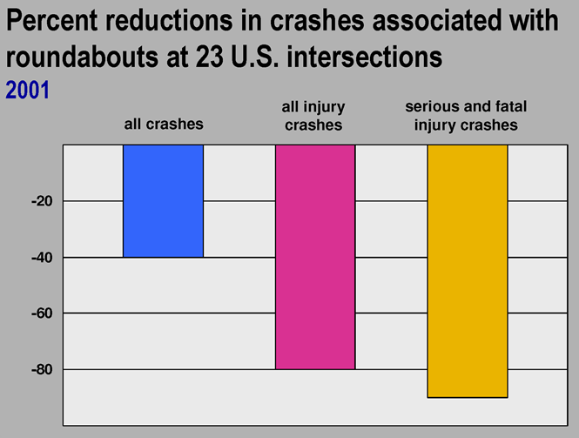
Figure 4: Reduction in Crashes after Roundabout Conversion (Insurance Institute for Highway Safety, 2006)
A study conducted by the Michigan DOT of all of the state’s roundabouts over a ten year period (Bagdade, 2011), found that single-lane roundabouts reduced the unadjusted rate of all crashes by 49%, reduced the rate of injury crashes by 79%, and reduced the rate of fatal and serious injury crashes by 88%. CMF values for conversion of all intersection types to roundabouts derived from this study was .488 for single and double lane roundabouts for all injury crashes. The derived CMF value for conversion of one or two way stop controlled intersections to roundabouts was .419. The derived CMF value for conversion of all way stop controlled intersections converted to roundabouts was .636. The derived CMF value for conversion of signalized intersections to single or double lane roundabouts was .300.
The substantial safety advantages provided by use of roundabouts over all other types of traffic control at intersections is reflected in crash modification factor (CMF) values published by the FHWA (FHWA, 2017). Broadly speaking CMFs are values which, when multiplied with the existing crash rate, equals the expected crash rate following an identified treatment. These CMFs are based on safety studies of treatments within well-defined conditions of traffic volume, road type, etc. For example, the value of CMF #5228 is .473 for fatal, serious injury and minor injury crashes when all types of traffic-controlled intersections are converted to a low-speed roundabout. This means that conversion of an intersection to a roundabout, within the conditions covered by this CMF, should reduce the crash rate by 52.7%. Other examples include CMF #221 with a value of .54 for minor injury crashes when stop-controlled intersections are converted to roundabouts. CMF #214 has a value of .68 for serious injury and minor injury crashes when signalized intersections are converted to roundabouts. CMF #215 has a value of .56 for serious injury and minor injury crashes when signalized intersections are converted to roundabouts. All of these CMFs show substantial reductions in serious crashes when an intersection with any type of traffic control is converted to a roundabout.

Intersection Throughput
Roundabouts exhibit a somewhat contradictory nature. By slowing traffic rather than stopping it, they increase throughput and allow people to get to their destination faster than other intersection treatments.
A study of three intersections converted to roundabouts in 2004 by the Insurance Institute for Highway Safety (Insurance Institute for Highway Safety, 2006) found reductions in delay following conversion ranged from 82% to 92%.

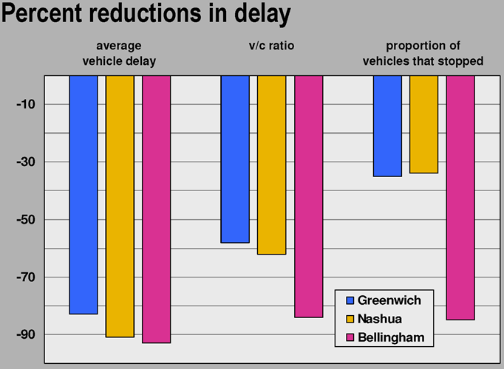
Figure 5: Delay of roundabouts versus intersections (Insurance Institute for Highway Safety, 2006)

The Kansas DOT found similar reductions in delay when they studied their roundabout conversions (Russell, 2004).

Cost
In 1998, NCHRP Synthesis 264 (National Cooperative Highway Research Program , 2017) stated that the average construction cost of 14 U.S. roundabouts, none being part of an interchange, was approximately $250,000. This amount includes all construction elements, but does not include land acquisition.
A 2000 report published by the FHWA (FHWA, 2000) cited costs of recent roundabout projects ranging from $10,000 to $500,000.
A 2010 FHWA study (FHWA, 2010) of five Maryland intersections converted to roundabouts cites costs ranging from $194,000 to just under $500,000.
According to the WSDOT (Washington State DOT, 2017), traffic signals cost from $250,000 to $500,000 with electric bills and routine maintenance amounting to about $8,000 a year. Over an estimated 15 year lifetime, maintenance costs total $120,000.
Costs for roundabouts vary widely depending on the right-of-way needed. When the cost of avoided crashes and the savings from reduced delay are included, lifecycle costs of roundabouts are similar or lower than signalized intersections due to their longer life (~30 years) and low maintenance costs.

Environmental
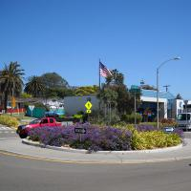
Roundabouts have been shown to produce environmental benefits due largely to their not requiring vehicles to stop, possibly idle for some time and accelerate back up to speed from a stop.
Figure 6 Center Island Treatment (Courtesy City of San Diego)
When cars are not required to stop or idle, noise due to the acceleration of stopped vehicles is reduced, air pollution due to idling cars is nearly eliminated, and fuel consumption is reduced.
According to a study by Desarnaulds (Desarnaulds, 2004), “The introduction of traffic lights coordination or roundabouts can locally reduce the noise from 1 to 2 dB(A)”. According to Vlahos (Evdokia Vlahos, 2008), the substitution of roundabouts for AWSC intersections results in an 18% reduction in CO emissions, a 49% reduction in CO2 emissions, a 12% reduction in NOx emissions, and a 17% reduction in HC.

Raised Median
In order to prevent mid-block left turns, eliminate head-on crashes and provide safety for pedestrians, the Road Diet Plus replaces the TWLTL with a raised median.
According to the 2015 NHTSA Traffic Safety Facts publication (National Highway Transportation Safety Agency, 2017), the third most common maneuver for all crashes was a left turn. The left turn was the third most common maneuver for fatal crashes and the second most common for injury crashes. Many of these left hand turns occurred at an intersection but a good number occurred in the segments between intersections. The elimination of the TWLTL removes all of its associated conflicts such as those resulting from poorly positioned opposing driveways or illegal passing maneuvers.
The safety improvements offered by a raised median may be affected by high rates of right turns, access management practices on the corridor, driveway density, etc.
It may be necessary to make the median mountable or to modify it in some way to accommodate the requirements of local fire departments for fire truck access.

Reduced Speed
A corridor which uses roundabouts as traffic control at intersections experiences significant traffic calming benefits.
The concept of the Roundabout Influence Area (RIA), defined in NCHRP Report 772 (Rodegerdts L. J., 2014), quantifies the impacts of roundabouts on a corridor’s vehicular speed. When placed in series, roundabouts operate in much the same way as successive speed bumps. Vehicles slow prior to entering the roundabout due to the entry speed being lower than the segment speed limit, they transit the roundabout at the slower, circulatory speed and accelerate out of the roundabout until the desired segment speed is reached. The extent of this upstream and downstream influence on vehicle speeds is known as the Roundabout Influence Area.
As with speed bumps, sufficiently close placement can keep produce a significant traffic calming effect. In cases where sequential RIAs do not overlap or are not contiguous, a driver’s knowledge that another roundabout is imminent can also serve to depress speeds.

Increased Available Width
The standard road diet normally frees a bit less than one travel lane width for reallocation to other uses. One travel lane is removed but a penalty is incurred because a TWLTL is usually wider than a normal travel lane. This results in eight to ten feet of liberated road width. This space may provide room for one-way painted bike lanes on each side of the street though space at intersections may be constrained.Traffic signal cycle lengths may require more lanes for storage or high turning movements may require dedicated turn lanes. In any case, a standard road diet normally provides only enough space for minimum width bicycle lanes.
The Road Diet Plus removes two full lanes and incurs a width penalty only for a raised median. This can liberate up to 20 feet of road width or more. This provides enough room for protected bicycle facilities in addition to other improvements. Use of roundabouts eliminates the need to increase the number of lanes at intersections for storage or signal delay. Incorporation of protected bicycle facilities at the roundabouts is dependent on the ROW available there and the roundabout size needed to meet project goals.

Complete Streets/Livability
It is difficult to measure the livability of a street. The reduction of a street from four or five lanes to two lanes with a median and roundabouts provides enough room for multimodal improvements in addition to opportunities for landscaping. Lower speeds reduce the noise and stress experienced on the street by all users. Crossing a street of two lanes with a pedestrian refuge island between is a much lower stress experience than crossing the “sea of asphalt” wider corridors often provide.

Tradeoffs
One key assumption underlying Road Diet Plus is that the corridor retains sufficient throughput to meet the desired performance goals. Significant factors deserving of consideration are the following.

Heavy Vehicles
In order to fit a roundabout within the available right-of-way, it may be necessary to reduce the size of vehicles allowed to use the roundabout or limit them to through movements only. A larger design vehicle requires a larger roundabout. Use of mountable aprons on the center island and the approaches can help with this problem but may not be sufficient on their own.

Speed Limit
Higher roundabout speed limits correspond to larger diameter designs. It may be necessary to reduce the posted speed limit within a roundabout to 15 MPH or less in order to fit a roundabout within the available right-of-way. Smaller roundabout designs may reduce the ability of entering drivers to discern whether circulating motorists coming towards them are leaving the roundabout or continuing toward them. This may reduce entry capacity. Good design and/or accurate modeling can address these issues.

Turning Movements
Roundabout throughput capacity degrades as the proportion of left turns and U-turns rises. This relationship is difficult to predict formulaically. The guidance provided in NCHRP Report 672 (Rodegerdts L. B., 2010) shows an approximate drop of 1,000 vehicles/day in throughput for every 10% increase in left turn percentage. No guidance is provided for percentage of U-turns but this is expected to be similar or higher. Because a Road Diet Plus transforms all mid-block left hand turns into U-turns at the next roundabout followed by a right turn, the number of U-turns could be quite high depending on traffic characteristics, parking distribution and corridor access management. This aspect must be modeled if a concern about its impact exists. As the La Jolla Boulevard case study demonstrates, even small one-lane roundabouts can support high traffic volumes if low minor street volumes and low left turn percentages exist.

Familiarity with Roundabouts
The throughput capacity of roundabouts is highly dependent on drivers’ familiarity with them. Page 21-5 of Chapter 21 of the 2010 Highway Capacity Manual (8) states “U.S. drivers presently seem to display more hesitation and caution in using roundabouts than drivers in other countries, which results in lower observed capacities. It is likely that capacities will increase in the future as U.S. drivers become more familiar with roundabouts.”
This evolution is illustrated in ODOT’s Excel implementation of the 2010 HCM roundabout capacity formula (Transportation Research Board, 2010). This capacity tool provides two different headways for the entry capacity calculations for a single lane roundabout. For the City of Bend, the only city in Oregon with a large proportion of roundabouts, the average headway is .0008 hours (approximately 2.88 seconds) which corresponds to a theoretical maximum of 1,333 vehicles/hour. For the remainder of the state of Oregon, the headway is .001 hours (approximately 3.6 seconds) which corresponds to a theoretical maximum of 1,130 vehicles/hour.
It may be necessary to estimate the proportion of drivers familiar and unfamiliar with roundabouts and an associated headway for each to predict the throughput of a roundabout and its corridor.

Emergency Vehicle and Public Transit Access
Many corridors must accommodate large public transit buses, fire trucks, and other large vehicles. Support for these vehicles may require larger diameter roundabouts.

Ability to Pass
Four lane roadways and, to a lesser extent, three lane roadways offer the ability to pass a stopped vehicle. In a Road Diet Plus corridor, vehicles stopping for any reason give following vehicles no alternative but to stop. It may be necessary to provide zones where vehicles can stop to allow legal maneuvers such as loading or unloading passengers, delivering packages, etc. This is particularly important if bus stops are located on the corridor.

Corridor Friction
Activities such as parking maneuvers occurring along the corridor generate friction and reduce the corridor’s throughput. Most of that friction occurs along the segments. At some point, the friction reduces segment throughput to the point that the roundabouts cease to be the corridor bottleneck. If high parking turnover, high pedestrian crossing rates, high bicyclist crossing rates or other friction-causing activities are expected, modeling may be required to predict corridor performance.

Feasibility Determination
There are many reasons for a community to consider a Road Diet Plus on a corridor. Goals can include:
- Traffic calming or traffic reduction,
- Multimodal improvements,
- Complete Streets implementation, and
- Downtown corridor renovation.
Whether a Road Diet Plus can achieve these goals is a context-sensitive projection. Factors in this decision include current and projected values for:
- Vehicular Traffic Characteristics such as speeds, turning movements, stopping or slow-moving vehicles, origins and destinations, crash patterns, transit use;
- Multimodal Characteristics such as bicycle volumes and patterns, pedestrian volumes and patterns;
- Supra-roadway Aspirations such as livability, comfort, beautification, economic vitality;
- Concomitant Policy Changes such as access management directives, enforcement programs, transportation network planning, land use and zoning changes, etc.
It is not within the scope of this guide to consider all of these factors. Because this guide only aims to support a high-level decision whether to continue investigation of a Road Diet Plus, it concentrates on the two most important factors. The first is the right-of-way available at each intersection for the desired roundabout design. The second is the traffic volume and turning movements the corridor must support.

Philosophy of Feasibility Determination
The RDG provides maximum ADT volumes used by three public agencies to assess whether a standard road diet is worth considering. The RDG does not state whether these volumes are current volumes that provide sufficient margin for future growth, absolute ceilings, or whether they are influenced by factors such as short block lengths which can make a road diet on a signalized corridor difficult.
This guide’s aim is to provide evidence-based upper limits for vehicular throughput at which a corridor based on single-lane roundabouts and 2-lane segments can operate successfully.

Basis for Feasibility Projections
When assessing feasibility, one often triangulates from a combination of theoretical and practical information. For the Road Diet Plus, the La Jolla Boulevard corridor in San Diego, CA is the pinnacle of on-the-ground data. It is the only known American example of a 4- or 5-lane corridor renovated with single-lane roundabouts and 2-lane segments with a raised median. In addition to its unique status, the high traffic volume on this corridor is foundational to this guide.
The portion of La Jolla Boulevard running through the Bird Rock neighborhood in San Diego formerly existed as an undivided, 5-lane street supporting 22,000 vehicles/day at speeds of 40 – 45 MPH. It was converted to a roundabout corridor between 2005 and 2008 using compact urban roundabouts and 2-lane segments with a raised median.
An important aspect of the La Jolla Boulevard example is the throughput of its small roundabouts approaching and likely exceeding the theoretical maximum capacities predicted by the 2010 HCM (Transportation Research Board, 2010) models without congestion problems. The limitations of the HCM models are discussed in NCHRP 772 (Rodegerdts L. J., 2014) and work is underway to create models which more accurately reflect current American observations. The inability of the theoretical models to estimate throughput for a roundabout corridor forced a reliance on practical data which was provided by the La Jolla Boulevard corridor.
Other corridors using single-lane roundabouts with 2-lane segments were examined for guidance on throughput ceilings and those findings are included in Appendix C. A portion of the traffic count data obtained for La Jolla Boulevard is provided in Appendix A and is used later in this guide.

Right-Of-Way Needed for Roundabouts
Roundabouts often have a larger footprint than standard intersection treatments. This can be a significant obstacle to intersection renovation where significant development already exists.
Despite occupying more area than standard intersections, roundabouts reduce right-of-way requirements for the segments connecting them. This is known as the Wide Nodes, Narrow Roads concept. This property makes roundabouts well-suited for a Road Diet Plus.
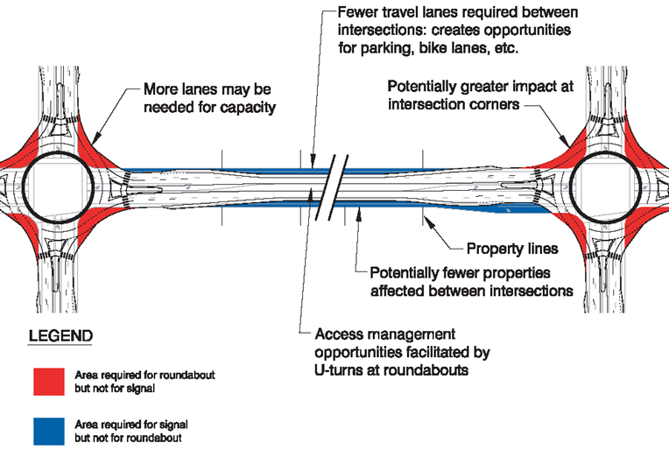
Figure 7: Wide Nodes, Narrow Roads Concept (Rodegerdts L. B., 2010)
In order to determine whether enough right-of-way is available at existing intersections, one needs to know the true diameter of the roundabout treatment. One of the most common measures of roundabout size is the ICD or Inscribed Circle Diameter. This is the diameter of the outside edge of the roundabout’s travel lane known as the circulatory roadway.
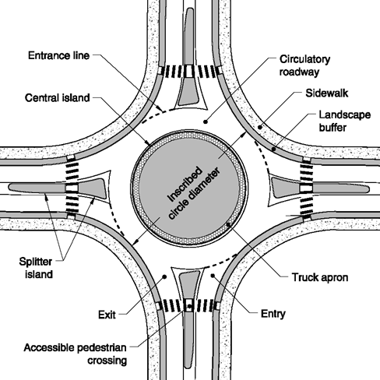
The ICD does not communicate the right-of-way needed for a fully implemented roundabout. In addition to the circulatory roadway, one normally includes a landscape buffer and sidewalk or shared use path as shown in Figure 8. Bicyclists can be provided with a separate pathway alongside the sidewalk or, where low volumes are expected, put onto a widened sidewalk creating a short section of shared use path. MUTCD Section 9C.04 specifically prohibits marked bike lanes in the circulatory roadway and expecting cyclists to mix with traffic through a roundabout is likely ill-advised in a corridor being considered for a Road Diet Plus conversion.
Figure 8 Roundabout Diagram with ICD (Rodegerdts L. B., 2010)
The ICD makes up the majority of the space needed by a roundabout. Reducing the ICD can be the key to a feasible Road Diet Plus. Some of the largest factors driving the ICD dimension are:
- Speed within the circulatory roadway,
- Design vehicle size and permitted movements through the roundabout,
- Desired throughput, and
- Accommodation of non-orthogonally aligned or skewed approaches.
In order to fit a roundabout into available right-of-way, it may be necessary to adjust some of these factors.
Design vehicle size makes a huge impact on the ICD. Reducing the size of vehicles that a roundabout is required to support by re-routing of large trucks or limiting those trucks to through movements by prohibiting truck traffic on the minor streets may be necessary.
Speed within the circulatory roadway is an easier factor to control. Dropping speeds to 15 MPH or less can help shrink the ICD. Speeds this low still offer significant throughput advantages over standard intersections.
Needed throughput and skewed approaches are more difficult to address. Traffic diversion from the corridor may help meet throughput goals with a smaller roundabout but accommodation of skewed approaches often requires additional ROW or clever design alternatives such as non-circular central islands.
While investigating a number of corridors where this type of conversion has occurred, I measured what I consider the true diameter of the roundabouts. This “true diameter” included the landscape buffer and sidewalk that surrounded the roundabout. None of the examined corridors included dedicated bikeways at their roundabouts; as of July 2017 it appears that no such roundabout exists in the U.S.
Below is a table which allows one to determine the true diameter of the roundabout needed to accommodate the throughput required in a corridor. If a dedicated bikeway or other additions are desired, those dimensional impacts should be added to the diameter listed in the table. One must be sure to add twice the width of the improvements to the diameter to get the true diameter. Because roundabout throughput is dependent on a number of factors, a range is provided for each size. Roundabout size is categorized by the taxonomy provided by the 2000 FHWA Roundabout guide (FHWA, 2000) and is limited to the urban compact and urban single-lane choices. Daily service volumes from this taxonomy are not used because their overly-conservative values unduly limit consideration of these alternatives. Multilane roundabouts are not considered in this guide.

Table 1: Roundabout Diameter Determination
 | Turning & Minor Street Traffic Percentage
 | < 10% Left/U-Turn/Minor Traffic | > 10% Left & U-Turn/Minor Traffic
Desired Throughput
Up to 25,000 veh/day | 110’  (Urban Compact) | 140’  (Urban Single Lane)
Up to 30,000 veh/day | 140’  (Urban Single Lane) | N/A

This table rests on a number of assumptions. Those assumptions are:
- The La Jolla Boulevard experience shows that a corridor with low percentages of left turns and minor street traffic can support at least 23,000 vehicles per day using urban compact roundabouts (ICD between 90 and 100 feet) and simulations of that corridor show that up to 27,000 vehicles per day is possible (Rodegerdts L. J., 2014). 25,000 veh/day has been selected as a compromise between those values.
- Experience with near-maximum capacities of urban single lane roundabouts (SLRs) in a corridor was not available. Extrapolation of a maximum capacity for urban SLRs was done by adding the difference between the stated capacity in NCHRP 672 (Rodegerdts L. B., 2010) for urban compacts (15,000 veh/day) and a capacity of 25,000 vehicles per day supportable by the La Jolla Boulevard data to the stated capacity in NCHRP 672 (Rodegerdts L. B., 2010) for urban single-lanes (20,000 veh/day), i.e. (25,000 - 15,000) + 20,000 = 30,000 veh/day. This is an admittedly-simple approximation.
- The 10% limit on left turns, U-turns and minor street traffic come from turning movements data on La Jolla Boulevard. That data showed values from 7 to 10%.
- Throughput numbers for La Jolla Boulevard indicate a high proportion of drivers familiar with the roundabouts on that corridor, their ability to accept smaller gaps upon entry, and a concomitant increase in throughput. This is supported by the traffic data which shows a distinct commute pattern. Corridors with a higher proportion of unfamiliar drivers will experience lower throughput.
- Friction associated with pedestrian and bicyclist activity is included in the volumes found in this table. The pedestrian and bicycle volumes implicit in these numbers are not exactly known. A pedestrian and bicycle study performed on January 8, 2014 at the La Jolla Boulevard and Forward Street roundabout (in Appendix B) showed a range of 62 - 118 pedestrians/hour for the 2-hour periods monitored in the morning commute, lunch hour and evening commute periods. The same study showed a range of 13 - 30 bicycles/hour for the 2 hour periods monitored in the morning commute, lunch hour and evening commute periods.
After a roundabout diameter is determined for each intersection, one can use the distance measurement tool on Google Maps or similar tool to evaluate whether sufficient right-of-way is available for conversion.

Traffic Volumes
The RDG includes a list of agencies and the maximum corridor traffic volumes they refer to when considering a standard road diet. When considering a standard road diet, the City of Pasadena, CA uses 15,000 ADT as its ADT ceiling, the City of Lansing, MI uses 18,000 ADT, and the City of Seattle, WA uses 25,000 ADT. It should be noted that issues with signalization, for example the possibility of queue formation when short distances between signalized intersections exist, can be the limiting factor for road diets rather than the underlying roadway capacity. This may explain the large range seen in this list. Another possible reason for the large range is the use of those maximums. From the RDG, it isn’t clear if those values are current volumes which provide headroom for years of traffic volume growth or if they represent the target volumes a road should support at some point in the future.

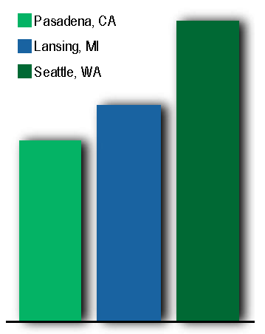
25,000
18,000
15,000
Figure 9: Standard Road Diet Maximum Volume Thresholds by Agency (Knapp, 2014)
Appendix A provides traffic count data for La Jolla Boulevard on a day for which the ADT was 22,925, a value the City cited in NCHRP 772 (Rodegerdts L. J., 2014) as commonplace. The peak hour volume was 2134 (8:45 AM - 9:45 AM) and the peak 15 minute volume was 583 (8:45 AM - 9:00 AM). The theoretical peak hour volume calculated from the peak 15 minutes is 2332 vehicles/hour, corresponding to a single lane volume of 1166 vehicles/hour.
One statement made by the City of San Diego representative during the interview for the NCHRP 772 (Rodegerdts L. J., 2014) study was that their simulations had showed the roundabouts capable of handling 27,000 ADT. Using the proportions seen in the traffic count data, this corresponds to a theoretical peak hour volume of 2,747 vehicles/hour and a single lane volume of 1374 vehicles/hour. This value lies above the maximum capacity predicted by the current HCM roundabout capacity model (Transportation Research Board, 2010) and confirms the conclusion reached in NCHRP 772 about the need to update capacity models for American roundabout corridors.
The first thing to note about these values is that the 22,925 ADT is well above two of the three ADT maximum thresholds listed in the RDG and nearly equals the highest threshold used by the City of Seattle, WA. Yet the City of San Diego receives no complaints of congestion on La Jolla Boulevard and has no concerns about level of service on this corridor. What is the reason for this?
NCHRP 772 (Rodegerdts L. J., 2014) shows that substitution of roundabouts for signalized intersections can allow a Road Diet Plus to function more safely at higher traffic volumes than a standard road diet. The throughput advantage proffered by roundabouts is the key that allows a Road Diet Plus corridor to outperform a standard road diet corridor. As also demonstrated by the results of 772 (Rodegerdts L. J., 2014), this will not be true for all corridors.

Roundabout Throughput Degradation by Left-Turns
One oft-cited aspect of roundabouts is the throughput degradation that occurs as the proportion of left turn movements increases. I found no discussion of the impact of U-turns in the literature but one assumes that their throughput-degrading impact is at least as great as left-turns.
The conversion of all mid-block left-turns into U-turn/right-turn sequences has the potential to degrade a roundabout’s throughput. The general guidance provided by Exhibit 3-12 of NCHRP 672 (Rodegerdts L. B., 2010) suggests a degradation of 1,000 vehicles/day for each 10% increase in left-turn percentage up to a value of 40% of total volume. This is a rough approximation. Though not explicitly stated, one might guess that Exhibit 3-12 and the linear relationship between left-turn percentage and roundabout throughput is based on the formula for roundabout throughput at an entry. No comparison is made between the formula-derived relationship and observational data. Data and/or guidance beyond the 40% limit was not found and a linear relationship cannot be assumed above that value.
The volume counts and turning movement data from La Jolla Boulevard implicitly include all left turns and U-turn/right-turn combinations generated in that corridor by the removal of all mid-block left-turns. The left-turn percentage for all traffic seen in the peak times for the La Jolla Boulevard and Forward Street roundabout is 7%. Unfortunately, this aspect is not easily generalizable and a corridor’s traffic characteristics must be evaluated on its own terms.

Roundabout Throughput Degradation by Minor Street Traffic Volumes
A generally accepted aspect of roundabouts is that they function best when the volumes on all approaches are approximately equal.
The data from La Jolla Boulevard suggests another scenario for high roundabout throughput. With left-turn percentages at 7% of total volume and minor street traffic volume at 8% of total volume, the roundabouts begin to approach the status of a simple horizontal deflection for the majority of corridor traffic. As left-turn and minor approach percentages approach zero, the roundabout begins to operate solely as a traffic calming device.
Again, this aspect is not generalizable and a corridor’s traffic characteristics must be evaluated on its own terms.

Impact of Pedestrian and Bicycle Activity on Corridor Throughput
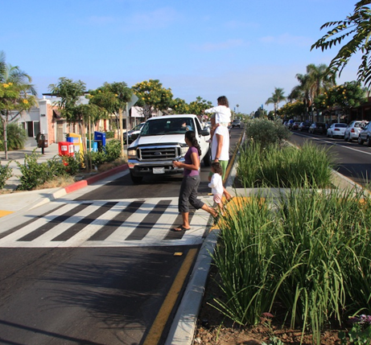
Because one of the biggest rewards to a Road Diet Plus is the creation of a more attractive, multimodal street, one must consider the impacts made by pedestrian and bicycle activity on the corridor’s performance.
Figure 10: Family Crossing (Courtesy Blue Zones)
The traffic count and turning movement data from the La Jolla Boulevard corridor (Appendix A) include the impacts of pedestrian and bicycle activity in that corridor, in addition to friction from other activities such as parking maneuvers. Data from the pedestrian and bicycle study performed on January 8, 2014, shows a range of pedestrian activity from 62 pedestrians/hour to 118 pedestrians/hour for the 2 hour periods monitored in the morning commute, lunch hour and evening commute periods. The same data shows a range of bicycle activity from 13 bicycles/hour to 30 bicycles/hour for the 2 hour periods monitored in the morning commute, lunch hour and evening commute periods. With low minor street traffic volumes and low left-turn percentages, pedestrian and bicycle activity parallel to the major street will not have as much impact as crossings of the major street.
Again, this aspect is not generalizable and a corridor’s characteristics must be evaluated on its own terms.

Case Study
In examining corridors in the United States renovated via the conversion of multiple intersections to roundabouts, I found only one with volumes high enough to assess the upper limits of throughput possible for a Road Diet Plus (the results of this work are contained in Appendix C). This corridor was La Jolla Boulevard from Camino De La Costa to Colima Street in San Diego, CA.
La Jolla Blvd was a five-lane street with a mix of signalized and AWSC intersections and supported volumes of 22,000 vehicles per day at speeds of 40-45 MPH. At one time it was a part of Highway 101.
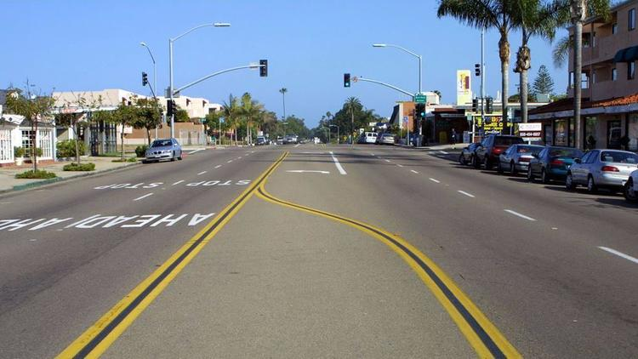
Figure 11: La Jolla Boulevard before its renovation (Courtesy Dan Burden and San Diego Union Tribune)
Residents and corridor businesses demanded a safer, more comfortable street that would encourage commerce. After extensive neighborhood interaction and traffic studies, this corridor was transformed between 2005 and 2008 to include a series of five small-diameter roundabouts and two 10’ wide travel lanes separated by a landscaped median. Diagonal parking with a buffer between the travel lane and parking stalls is provided on one side - the buffer reduces the impact of parking maneuvers on through traffic. Parallel parking exists in some locations on the other side. Bicycle lanes were added to both sides of the street.

Figure 12: La Jolla Boulevard after renovation (Courtesy Dan Burden and San Diego Union Tribune)
Following its transformation, La Jolla Boulevard experienced a 35% increase in trade, a 77% reduction in noise, and a dramatic reduction in fatalities (Jenkins, 2017).
La Jolla Boulevard is the only corridor that I was able to discover in my research to receive a Road Diet Plus type conversion. It is the only corridor renovated with roundabouts using two travel lanes and single-lane roundabouts.
The success of the La Jolla Boulevard conversion in terms of livability, increase in economic vitality and supported traffic volumes proves the feasibility of the Road Diet Plus concept.

Design of a Road Diet Plus
This guide’s purpose is to help determine whether moving forward with a Road Diet Plus is feasible. More detailed investigation and/or modeling will be needed for most corridors once preliminary feasibility has been confirmed.
A major component of the design work for a Road Diet Plus is design of the roundabouts. Roundabout design is outside the scope of this guide and should be performed by a knowledgeable, skilled engineer with substantial roundabout experience. It is much easier to design a roundabout which passes multiple engineering reviews and performs poorly on the ground than many realize. Roundabout design is a nuanced skill which takes years of experience to develop.
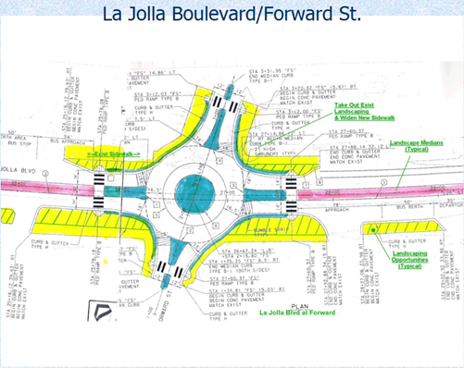
Particular attention should be paid to the design of pedestrian and bicycle facilities at roundabouts. Some studies have shown decreased safety for pedestrians and bicyclists after conversion of a standard intersection to a roundabout.
Figure 13: Plans for Forward St Roundabout (Courtesy City of San Diego)
Daniels (Daniels, 2009) conducted an extensive study of approximately 90 intersections which had been converted to roundabouts in the Flanders-Belgium area. Where on-street bike lanes were present, he found that conversions resulted in an increase in the total number of vehicle/bicycle crashes. Numerous articles document this study but the most pertinent is cited.
Design of corridor segments require similar attention. Transit use, access management, pedestrian and bicycle volumes/patterns, emergency vehicle access, parking lanes, transitions into and out of the corridor, rates of turning movements, etc are just some of the factors which must be considered. Some of the items listed in the exploration of design issues in the RDG are applicable to the Road Diet Plus as well.

Assessment of a Road Diet Plus
The goals of a particular Road Diet Plus conversion are the items at which a post-implementation analysis should be targeted. In addition, a clear expectation and set of requirements should be established for those characteristics which are intended to remain unchanged or only slightly affected. Both types of goals can, and should, be assessed through data collection and examination.
Goals for street improvement projects normally fall into safety and operational categories. Data for studying these goals, e.g. speed, often overlap.
The data needs for assessing goal attainment can vary. When gathering data for a post-implementation analysis, thought should also be given to collecting the data needed for diagnosis of any problems that may have arisen. For example, if queues are forming at a roundabout entry, data on turning movements, vehicle speed, vehicle mix, acceptance gaps, following gaps, pedestrian and bicycle crossings, etc should be gathered to help with evaluation of the roundabout’s performance.

Data Needs
Data needed for the assessment of safety and operational goals include but are not limited to the following:
- Speed and variance - data which informs capacity, crash rate and severity
- Calculated LOS and QOS for all modes - corridor performance for all modes
- Yielding rates to ped/bicycle - this is important to active travel comfort
- Volumes for all modes, ADT and peak - corridor performance for all modes
- Left turn and U-turn percentages in roundabouts (turning movements data)
- Right turn movements on segments
- Queue lengths (if they exist) and entry delays at roundabouts
- Vehicle mix - this is important for roundabout capacity and segment capacity
- Parking turnover - need info on parking friction affecting segment capacity
- Bus use and delays - includes delay to buses and delay to vehicles from buses
- Minor street traffic delays - need to assess minor street performance
- Livability factors – noise levels, air quality, people’s opinions of the corridor
- Economic factors - business volume in the corridor

Conclusion
The Road Diet Plus is borne from the convergence of the standard road diet, the safety advantages of the modern roundabout, and the throughput advantages of the modern roundabout in a corridor.
The only known example of a Road Diet Plus conversion has shown that it can support higher traffic volumes than a standard road diet while dramatically increasing safety, livability, and liberated right-of-way.
The ability of a Road Diet Plus to support higher traffic volumes means that corridors which are not candidates for a standard road diet may be suitable for a Road Diet Plus conversion.
As the only discovered execution of a Road Diet Plus conversion, La Jolla Boulevard in San Diego, CA demonstrates the potential of this strategy. But data from La Jolla Boulevard must be judiciously evaluated. La Jolla Boulevard only supports through movements of WB-50 vehicles. It appears to have a strong commute pattern during its busiest times of day. This implies that drivers are familiar with the corridor and roundabout throughput is high because of that familiarity. Minor street volumes and left turn volume percentages are low compared to corridor through volumes and these low conflicting volumes appear to support higher through volumes. Driveway density was reduced in this corridor removing the friction of more numerous access points. Despite these cautions, this corridor is an excellent example of the application of a Road Diet Plus to a 5-lane corridor.
Another lesson from the La Jolla Boulevard example is the difference between roundabout throughputs given in national guidance and what actually occurs in a corridor as drivers become more familiar with the use of roundabouts. The conservative projections for roundabout throughput in the published guidance may hinder roundabouts’ wider consideration or application to busier corridors.
The Road Diet Plus’ use of roundabouts to eliminate TWLTLs is a standalone strategy which can be used on any corridor with a TWLTL. Not only will the corridor receive the safety and throughput benefits of the roundabout but it should gain the safety benefits of removing all left hand turns from the corridor as well. This is in addition to the road width liberated by TWLTL removal.
The 2014 NCHRP Report 772 (Rodegerdts L. J., 2014) examined corridors across the United States renovated with roundabouts at major intersections. This study focused almost entirely on vehicle throughput and found that most corridors improved after conversion. They called out La Jolla Boulevard as an exception because the goals of that project centered on livability and traffic calming rather than improvement of vehicular throughput.
But NCHRP Report 772 (Rodegerdts L. J., 2014) missed one of the most valuable aspects to such a conversion. The dramatic increases in safety and livability provided by a roundabout-based corridor has the potential to positively transform many downtown and business corridors across the nation. A follow-on study to quantify the safety and environmental impacts of this type of conversion is needed. Quantification of these effects could be foundational to changing streetscapes everywhere.

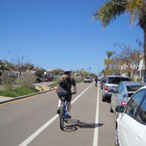
Figure 14: La Jolla Boulevard (Courtesy www.restreets.org)

References
Bagdade, J. P. (2011). Report Number RC-1566 Evaluating the Performance and Safety Effectiveness of Roundabouts. The Michigan Department of Transportation.
Burden, D. L. (1999, March). Road Diets: Fixing the Big Roads. Walkable Communities. Retrieved July 2, 2017, from www.walkable.org/download/rdiets.pdf
Daniels, S. B. (2009). Injury crashes with bicyclists at roundabouts: influence of some location characteristics and the design of cycle facilities. Journal of Safety Research, 141-148. doi:10.1016/j.jsr.2009.02.004
Desarnaulds, V. M. (2004). Noise Reduction by Urban Traffic Management. Proceedings ICA.
Evdokia Vlahos, A. P. (2008). Evaluating the Conversion of All-Way Stop-Controlled Intersections into Roundabouts. Transportation Research Record No. 2078, 80-89.
FHWA. (2000). FHWA-RD-00-67 Roundabouts: An Informational Guide. Federal Highway Administration. Retrieved July 6, 2017
FHWA. (2010). Roundabouts - The Maryland Experience. Federal Highway Administration. Retrieved July 6, 2017
FHWA. (2017, July 2). Crash Modification Factors Clearinghouse. Retrieved from http://www.cmfclearinghouse.org
Insurance Institute for Highway Safety. (2006). The Case for Roundabouts: What the Research Shows. Annual Meeting AASHTO Subcommittee on Design. Orlando, FL: AASHTO.
Jenkins, L. (2017, February 16). Roundabout apostle comes full circle, revisits Bird Rock. San Diego Union-Tribune. Retrieved April 17, 2017, from http://www.sandiegouniontribune.com/news/columnists/logan-jenkins/sd-me-20170217-story.html
Knapp, K. C. (2014). FHWA-SA-14-028 Road Diet Informational Guide. Federal Highway Administration. Retrieved March 3, 2017, from https://safety.fhwa.dot.gov/road_diets/info_guide/rdig.pdf
National Cooperative Highway Research Program . (2017, July 6). NCHRP 264 Modern Roundabout Practice in the United States. Retrieved from www.onlinepubs.trb.org: http://www.trb.org/Design/Blurbs/153636.aspx
National Highway Transportation Safety Agency. (2017, July 6). National Center for Statistics and Analysis (NCSA) Motor Vehicle Traffic Crash Data Resource. Retrieved from https://www.nhtsa.gov/: https://crashstats.nhtsa.dot.gov/#/
Persaud, B. R. (2001). Safety Effects of Roundabout Conversions in the United States. Transportation Research Record 1751, Paper No. 01-0562.
Rodegerdts, L. B. (2007). NCHRP Report 572 Roundabouts in the United States. Transportation Research Board.
Rodegerdts, L. B. (2010). NCHRP Report 672 Roundabouts: An Informational Guide. Transportation Research Board.
Rodegerdts, L. J. (2014). NCHRP Report 772 Evaluating the Performance of Corridors with Roundabouts. Transportation Research Board.
Russell, E. M. (2004). K-TRAN Final Report KSU-01-04 Operational Performance of Kansas Roundabouts: Phase 2. Kansas State University.
Stamatiadis, N. K. (2011). Report KTC-11-19 Guidelines for Road Diet Conversions. Kentucky Transportation Center.
Transportation Research Board. (2010). Highway Capacity Manual. Transportation Research Board.
Washington State DOT. (2017, July 6). Traffic Operations. Retrieved from Washington State Department of Transportation: https://wsdot.wa.gov/Operations/Traffic/signals.htm

Appendix A LA JOLLA BOULEVARD TRAFFIC DATA

Appendix B LA JOLLA BOULEVARD PEDESTRIAN AND BICYCLE DATA

Appendix C ROUNDABOUT CHARACTERISTICS

This appendix documents the findings of the search for appropriate corridors for study.
The approach for this search was to use the database of roundabout corridors produced by the NCHRP 772 report and downselect from that set. The NCHRP 772 report was published in 2014. One of the primary purposes of NCHRP 772 was to evaluate the performance of roundabouts in a corridor setting as opposed to their use as an isolated intersection. This study found 58 corridors which included at least three roundabouts in series in the United States.
In selecting appropriate corridors for characterization from this group of 58, the following criteria were used:
- the corridor had to be composed of only two lanes with no left-hand turn lanes,
- the corridor had to use only single lane roundabouts, and
- the corridor could not include pairs of roundabouts servicing a highway interchange.
Filtering the NCHRP 772 dataset with these criteria produced a list of six roundabout corridors which are listed below.

Road Name | City | State | # Rbts | Length (mi) | Land Use | Access Management | Approx Year Built
La Jolla Blvd | San Diego | CA | 4 | 0.6 | Urban | Median, many driveways | 2005 and 2008
O'Neill Dr | San Juan Capistrano | CA | 4 | 0.9 | Suburban Residential | 1 median break, not many driveways | 2003
W. 8th Ave | Chico | CA | 3 | 0.8 | Suburban Residential | Full access | Between 2002 and 2005
Hagen Ranch Rd | Boynton Beach | FL | 5 | 2.2 | Suburban Residential | A few side streets | 1998 2004
Maple Island Rd | Springfield | OR | 3 | 0.2 | Suburban Retail | No driveways | 2002
Via Bella | Williamsport | PA | 3 | 0.3 | Urban Retail | No driveways | Between 2005 and 2008
Table 2 Roundabout Corridors from NCHRP 772 Meeting Criteria

Requests were made to all of the jurisdictions for traffic counts in these corridors. The corridors were examined via Google Maps and the diameter and composition of the roundabouts were assessed. Available traffic count data and roundabout characteristics from existing corridors provide a guide for corridor capacity. Where traffic count data was not available, surrounding land use was used to qualitatively estimate volumes.

La Jolla Boulevard

Aerial Views

Corridor
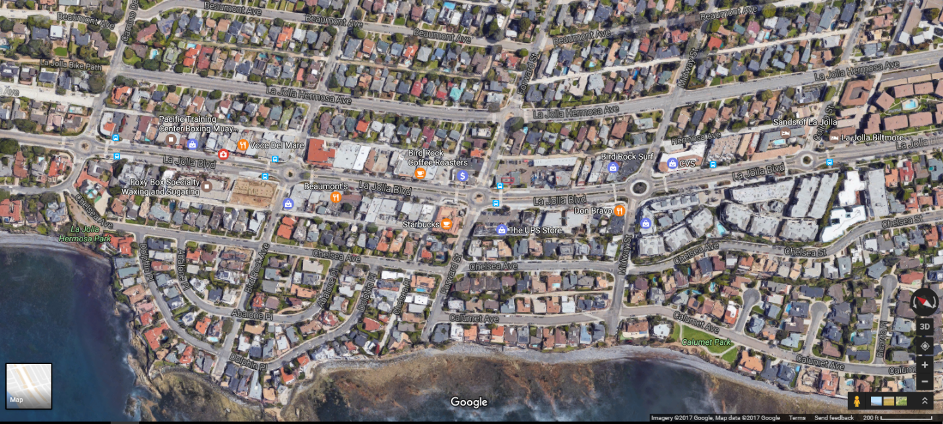

Camino De La Costa
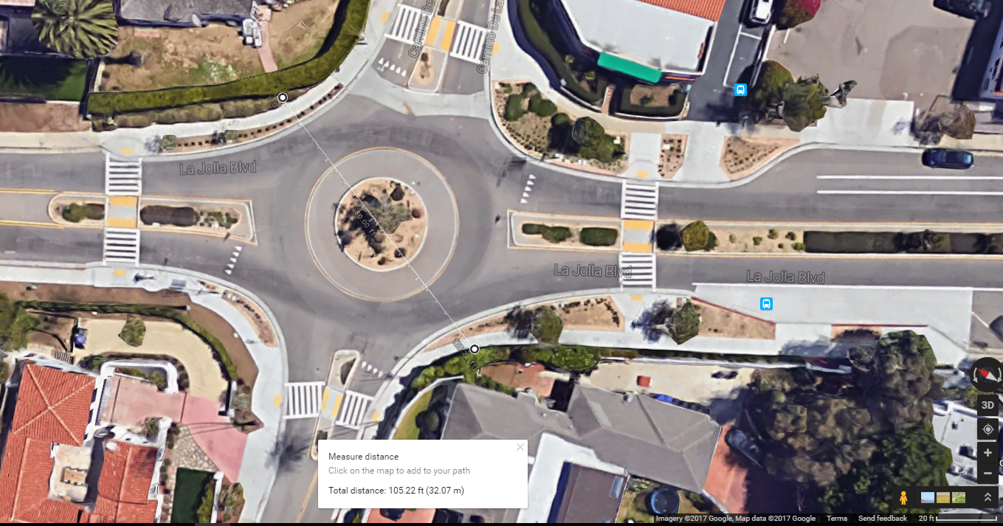

Bird Rock Avenue
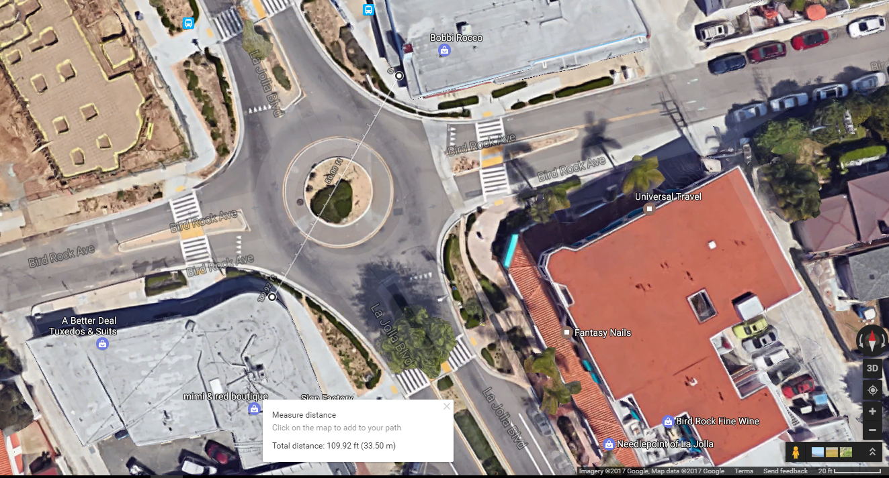

Roundabout Diameter and Composition
4-legged roundabout at Camino De La Costa and La Jolla Blvd with sidewalks on all sides, landscaping between sidewalks and circulatory lane, and bicycles apparently riding in the circulatory lane with diameter of 105 feet and a width of approach of 54 feet. Diameter and width are measured from outside of sidewalk to outside of opposing sidewalk. Width of approach is measured at the northern crosswalk which is approximately 43 feet from the edge of the circulatory lane. Speed limit on this corridor is posted at 25 MPH; signage for the roundabout entries advises a 15 MPH speed.
4-legged roundabout at Bird Rock Avenue and La Jolla Blvd with sidewalks on all sides, landscaping between sidewalks and circulatory lane, and bicycles apparently riding in the circulatory lane with diameter of 110 feet and a width of approach of 84 feet. Diameter and width are measured from outside of sidewalk to outside of opposing sidewalk. Width of approach is measured at the northern crosswalk which is approximately 45 feet from the edge of the circulatory lane. Speed limit on this corridor is posted at 25 MPH; signage for the roundabout entries advises a 15 MPH speed.

Traffic Count Data
As reported by the authors of the NCHRP 772 report (Rodegerdts L. J., 2014), San Diego City officials stated “The corridor serves an average daily traffic volume of 22,000 to 23,000 vehicles per day.” The same officials also said “The roundabout analysis conducted in SIDRA suggested that the single lane roundabouts could accommodate approximately 27,000 vehicles per day, thus allowing a three lane cross section to be implemented.”
Recent traffic count data supplied by the City of San Diego shows traffic volumes at various locations along the corridor ranging from over 15,000 ADT to 22,925 ADT on La Jolla Boulevard between Bird Rock Avenue and Camino De La Costa on Thursday, July 28, 2005. Per the City of San Diego, no complaints of congestion have been received for this corridor.
The traffic count and turning movement information shows that traffic through these roundabouts during peak periods are predominantly through-traffic on La Jolla Boulevard, the major street. Traffic on the minor street approaches was 9% of the total traffic at the intersection of La Jolla Boulevard and Forward Street on January 8, 2014. Left turn percentages for the same day and intersection, defined as the sum of all left turns on all approaches divided by the total traffic through the intersection, is 7%.
The low percentages of minor street traffic and/or left turns may be the explanation for why these roundabouts appear to be sustaining traffic volumes well above levels claimed for them in the published standards.

O’Neill Drive

Aerial Views

Corridor
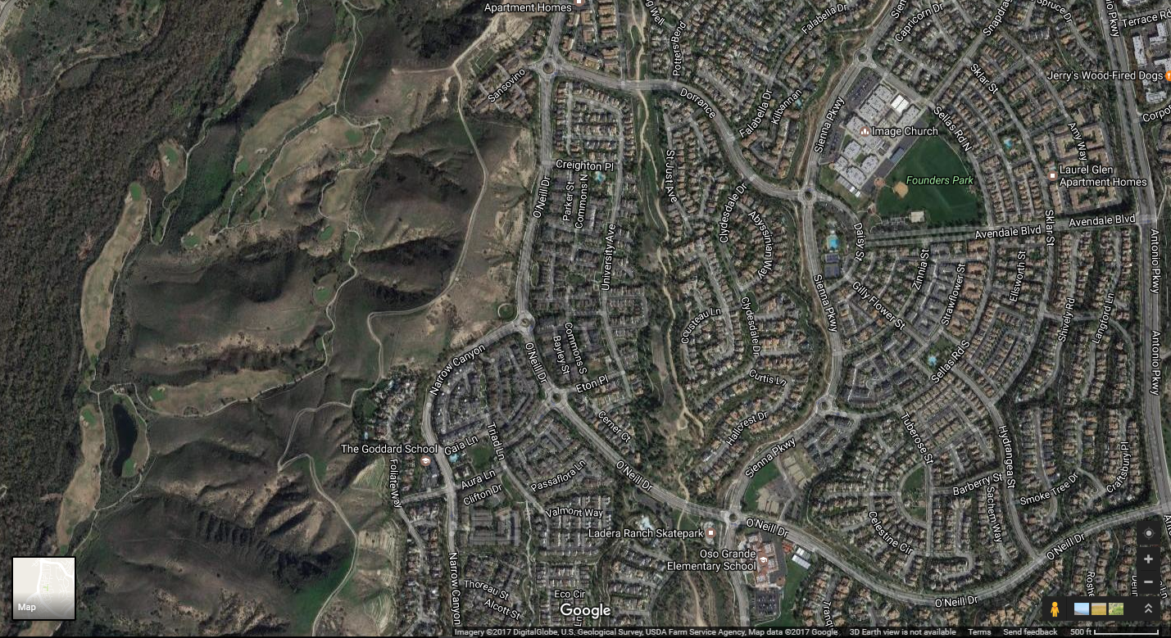

Eaton Place and O’Neill Drive
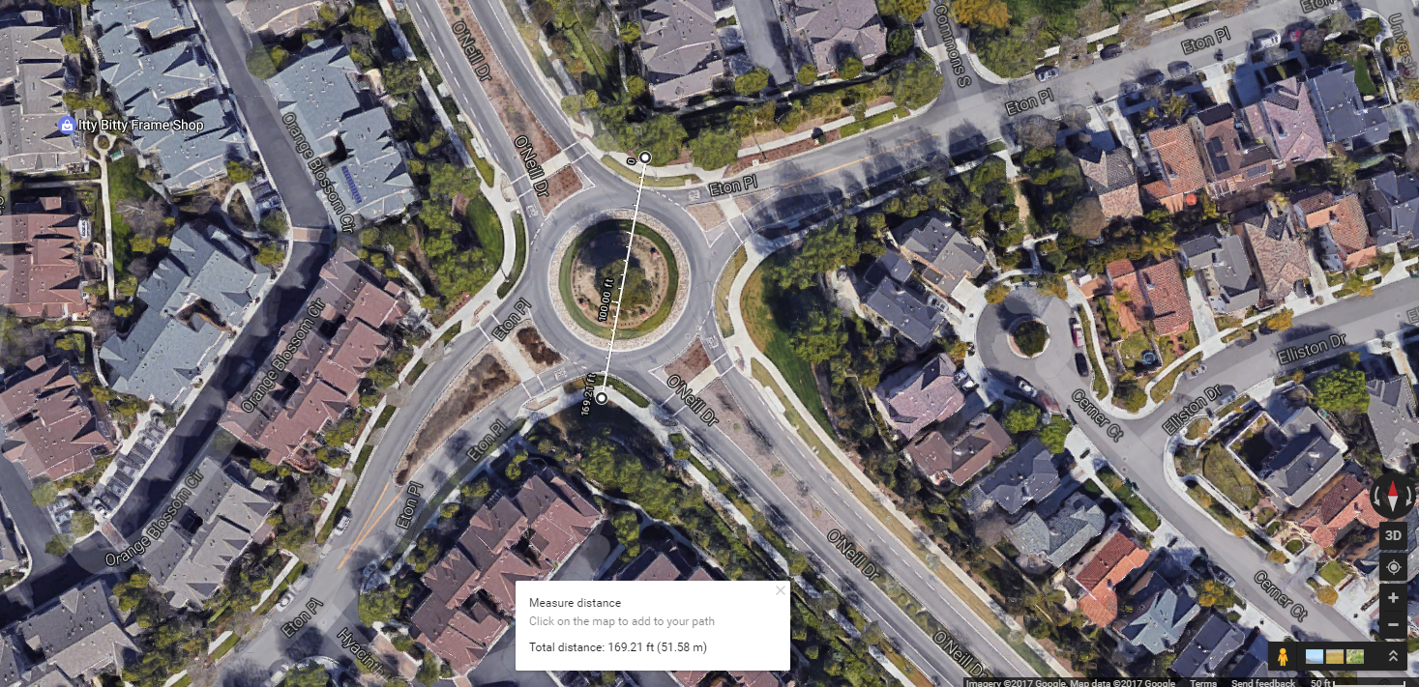

Senna Parkway and O’Neill Drive
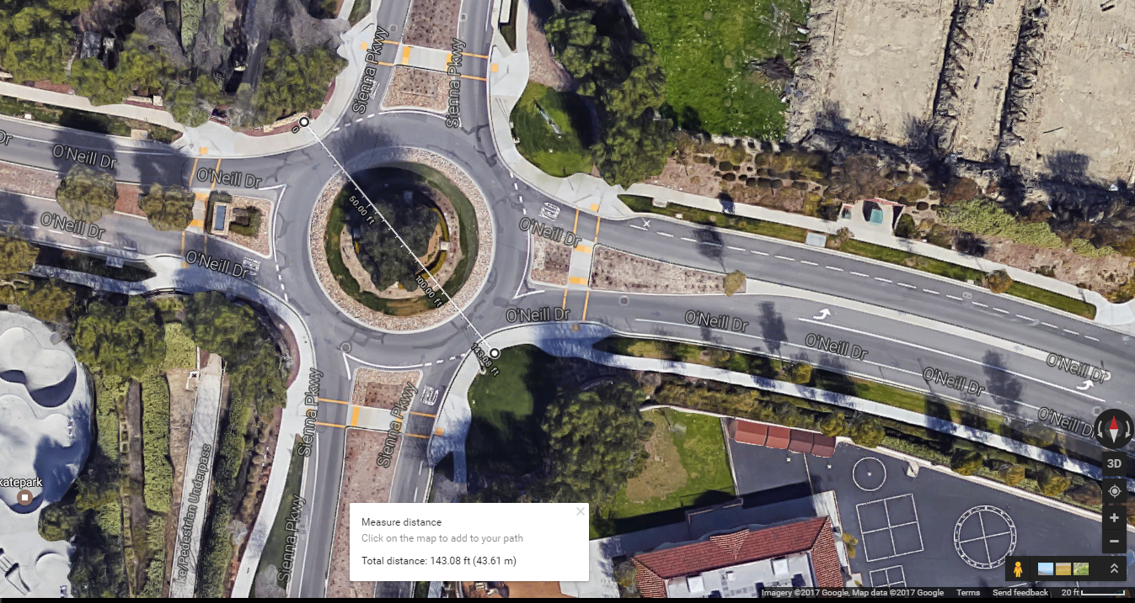

Roundabout Diameter and Composition
4-legged roundabout at Eton Place and O’Neill Drive with sidewalks on all sides, landscaping between sidewalks and circulatory lane, and bicycles diverted from road onto sidewalks with diameter of 170 feet and a width of approach of 97 feet. This roundabout has an unusually wide approach. Diameter and width are measured from outside of sidewalk to outside of opposing sidewalk. Width of approach is measured at the crosswalk which is approximately 30 feet from the edge of the circulatory lane. A speed limit is not posted on the roundabout-laced portion of the corridor but the posted speed limit on the street beyond is 45 MPH; signage for the roundabout entries advises a 15 MPH speed.
4-legged roundabout at Senna Parkway and O’Neill Drive with sidewalks on all sides, no landscaping between sidewalks and circulatory lane, and bicycles diverted from road onto sidewalks with diameter of 144 feet and a width of approach of 87 feet. This roundabout’s approach may be wider than necessary. Diameter and width are measured from outside of sidewalk to outside of opposing sidewalk. Width of approach is measured at the crosswalk which is approximately 27 feet from the edge of the circulatory lane. A speed limit is not posted on the roundabout-laced portion of the corridor but the posted speed limit on the street beyond is 45 MPH; signage for the roundabout entries advises a 15 MPH speed.

Traffic Count Data
No traffic count data was available for this corridor but surrounding land uses (mixed density residential neighborhood) suggest a commute pattern of traffic with light to moderate volumes.

8th Avenue

Aerial Views

Corridor
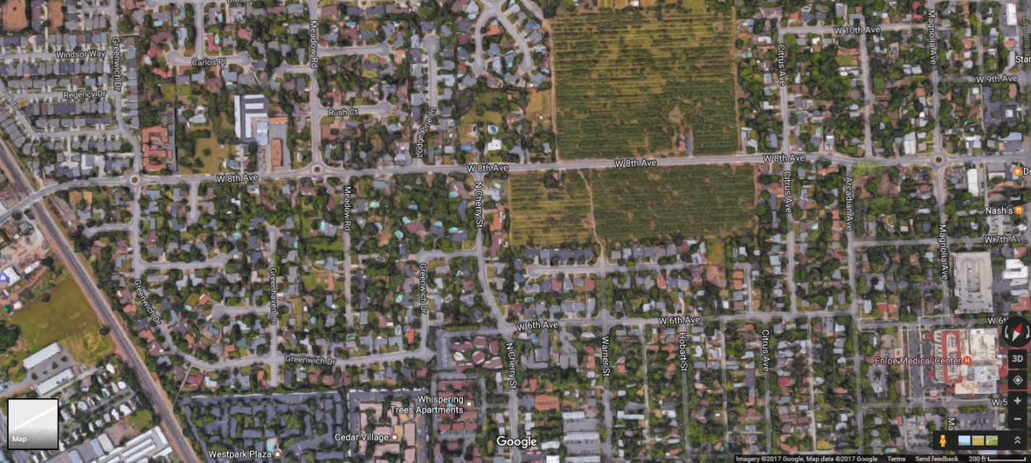

Greenwich Drive
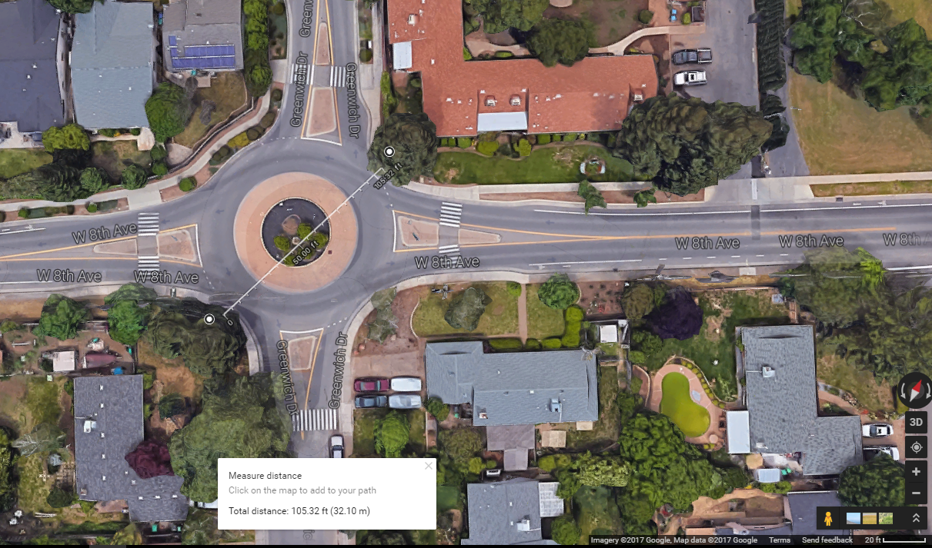

Magnolia Avenue
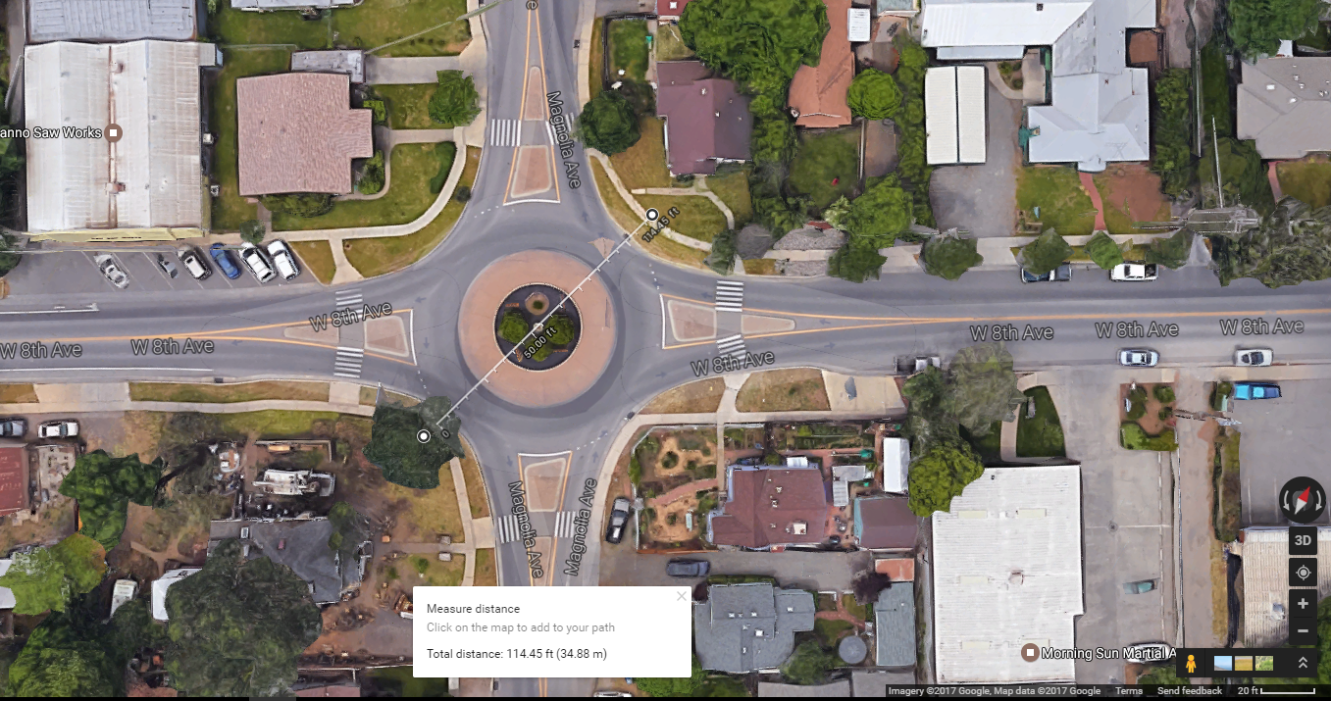

Roundabout Diameter and Composition
4-legged roundabout at Greenwich Drive and West 8th Avenue with sidewalks on all sides, no landscaping between sidewalks and circulatory lane, and bicycles apparently riding in the circulatory lane with diameter of 105 feet and a width of approach of 48 feet. Diameter and width are measured from outside of sidewalk to outside of opposing sidewalk. Width of approach is measured at the eastern crosswalk which is approximately 25 feet from the edge of the circulatory lane. Speed limit on this corridor is posted at 35 MPH for the western portion and 25 MPH for the eastern portion; signage for the roundabout entries advises a 15 MPH speed.
4-legged roundabout at Magnolia Avenue and West 8th Avenue with sidewalks on all sides, landscaping between sidewalks and circulatory lane, and bicycles apparently riding in the circulatory lane with diameter of 115 feet and a width of approach of 71 feet. Diameter and width are measured from outside of sidewalk to outside of opposing sidewalk. Width of approach is measured at the western crosswalk which is approximately 25 feet from the edge of the circulatory lane. Speed limit on this corridor is posted at 35 MPH for the western portion and 25 MPH for the eastern portion; signage for the roundabout entries advises a 15 MPH speed.

Traffic Count Data
The City of Chico keeps its traffic count information on their website at http://www.chico.ca.us/building_development_services/traffic/documents/2014_ADT_MAP.pdf. Two traffic count results are shown for West 8th Avenue. The 2010 count near Meadow Road shows 4,942 ADT and a 2014 count further east, near the Esplanade, shows 4,462 ADT. Both counts were recorded on West 8th Avenue.

Hagen Ranch Road

Aerial Views

Corridor
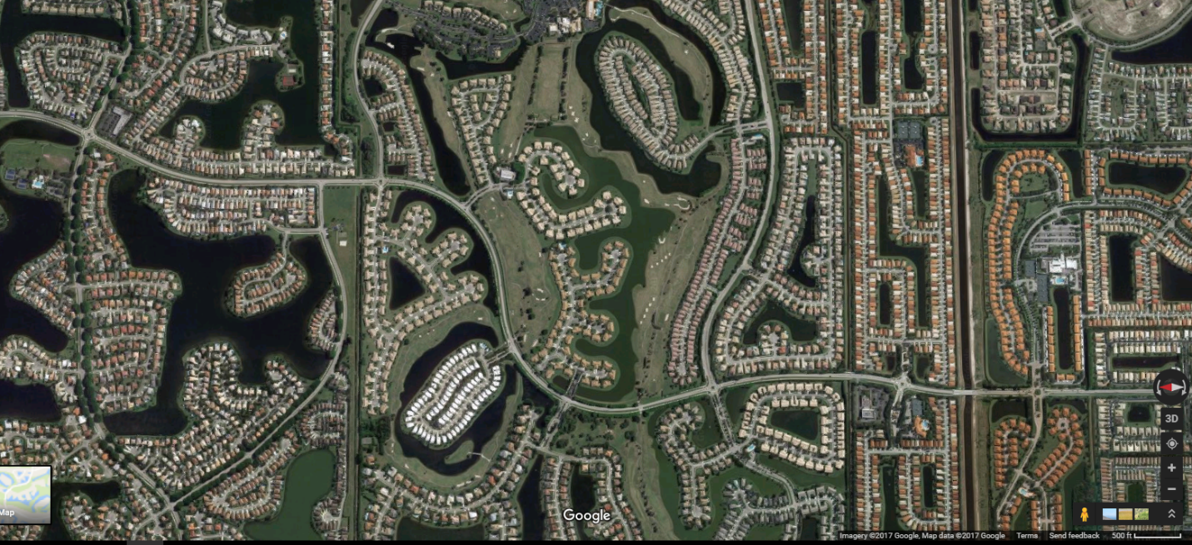

Majestic Palm Drive
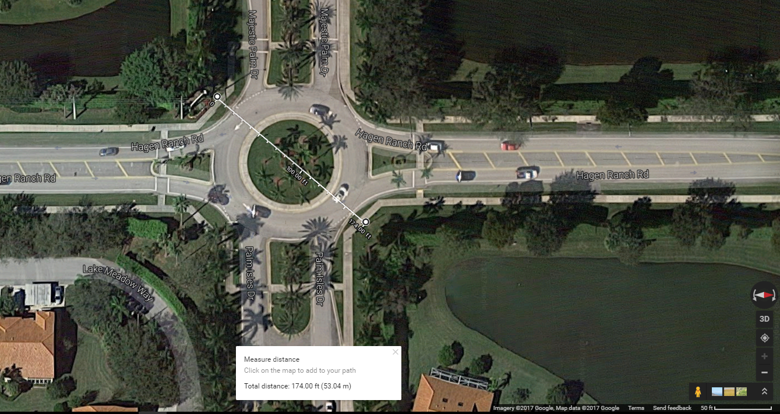

Le Chalet Boulevard
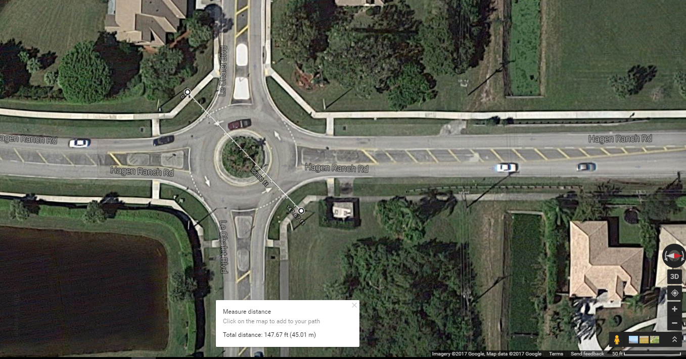

Roundabout Diameter and Composition
4-legged roundabout at Majestic Palm Drive and Hagen Ranch Road with sidewalks on all sides, landscaping between sidewalks and circulatory lane, and no bicycle facilities with diameter of 175 feet and a width of approach of 81 feet. Diameter and width are measured from outside of sidewalk to outside of opposing sidewalk. Width of approach is measured at the southern crosswalk which is approximately 43 feet from the edge of the circulatory lane. Speed limit on this corridor is posted at 45 MPH; signage for the roundabout entries advises a 15 MPH speed.
4-legged roundabout at Le Chalet Boulevard and Hagen Ranch Road with sidewalks on all sides, landscaping between sidewalks and circulatory lane, and no bicycle facilities with diameter of 148 feet and a width of approach of 83 feet. Diameter and width are measured from outside of sidewalk to outside of opposing sidewalk. Width of approach is measured at the southern crosswalk which is approximately 32 feet from the edge of the circulatory lane. Speed limit on this corridor is posted at 45 MPH; signage for the roundabout entries advises a 15 MPH speed.

Traffic Count Data
No traffic count data was available for this corridor but surrounding land uses (low density residential neighborhood) suggest a commute pattern of traffic with light to moderate volumes.

Maple Island Road

Aerial Views

Corridor
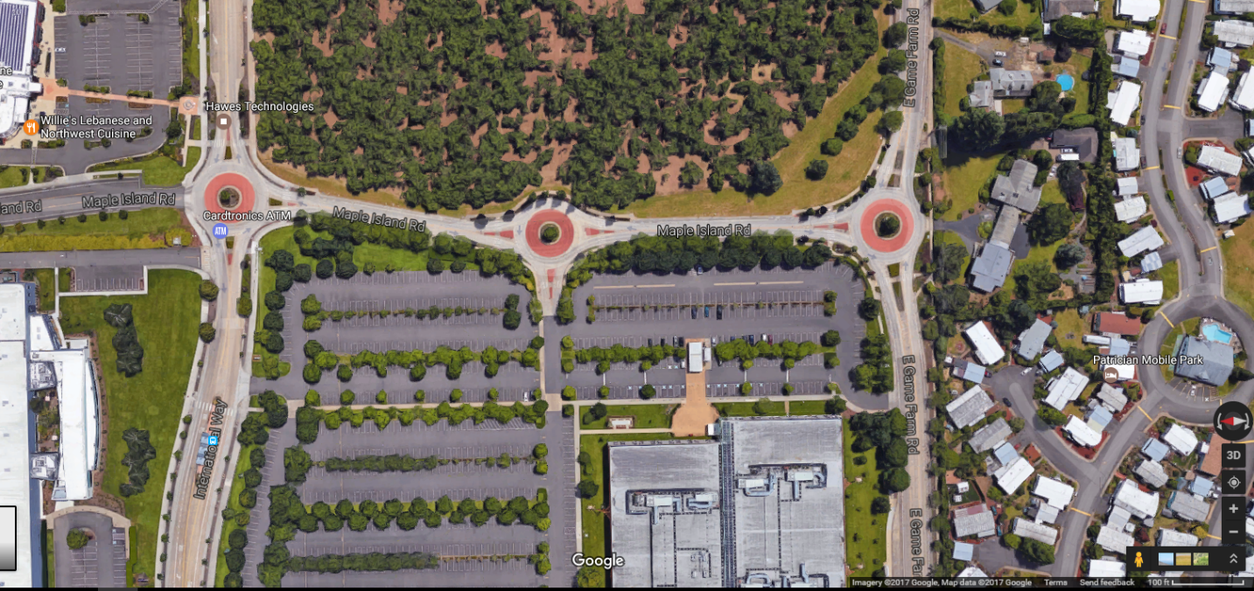

International Way
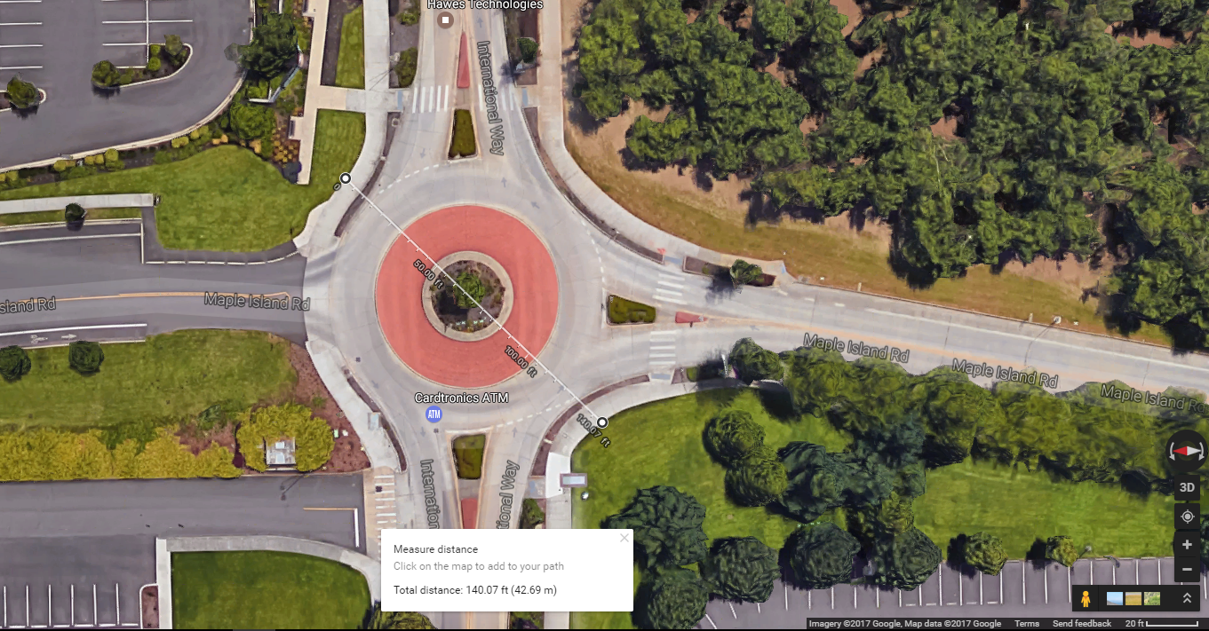

East Game Farm Road
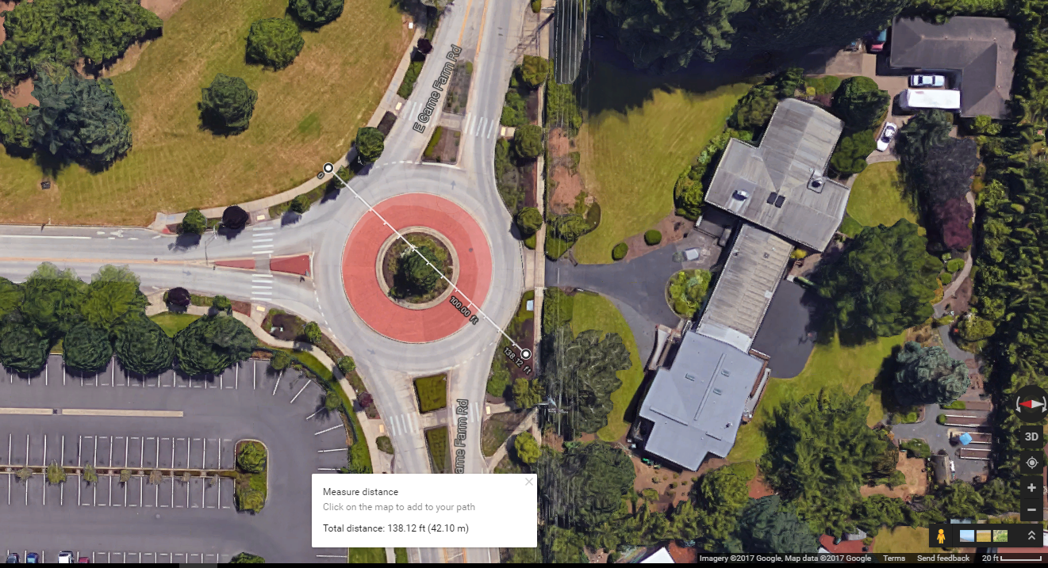

Roundabout Diameter and Composition
4-legged roundabout at International Way and Maple Island Road with sidewalks on all sides, landscaping between sidewalks and circulatory lane, and bicycles diverted from road onto sidewalks with diameter of 140 feet and a width of approach of 79 feet. Diameter and width are measured from outside of sidewalk to outside of opposing sidewalk. Width of approach is measured at the eastern crosswalk which is approximately 23 feet from the edge of the circulatory lane. Speed limit on this corridor is not posted but the roundabouts are so closely spaced that speeds likely remain low; signage for the roundabout entries advises a 15 MPH speed.
4-legged roundabout at East Game Farm Road and Maple Island Road with sidewalks on all sides, landscaping between sidewalks and circulatory lane, and bicycles diverted from road onto sidewalks with diameter of 138 feet and a width of approach of 68 feet. Diameter is measured using a supposed sidewalk position similar to the opposing sidewalk due to the distant location of the sidewalk on one leg of this roundabout. Diameter and width are measured from outside of sidewalk to outside of opposing sidewalk. Width of approach is measured at the northern crosswalk which is approximately 25 feet from the edge of the circulatory lane. Speed limit on this corridor is not posted but the roundabouts are so closely spaced that speeds likely remain low; signage for the roundabout entries advises a 15 MPH speed.

Traffic Count Data
The only traffic count data available for this facility was a PM peak hour count which counted 485 vehicles going through the roundabout on International from 4:30 PM to 5:30 0PM on Tuesday, 5/24/2011. A conversation with Kristi Krueger, Principal Transportation Engineer for the City of Springfield confirmed the moderate volumes on this corridor and that WB-50 vehicles could make left turns on these roundabouts.

Via Bella

Aerial Views

Corridor
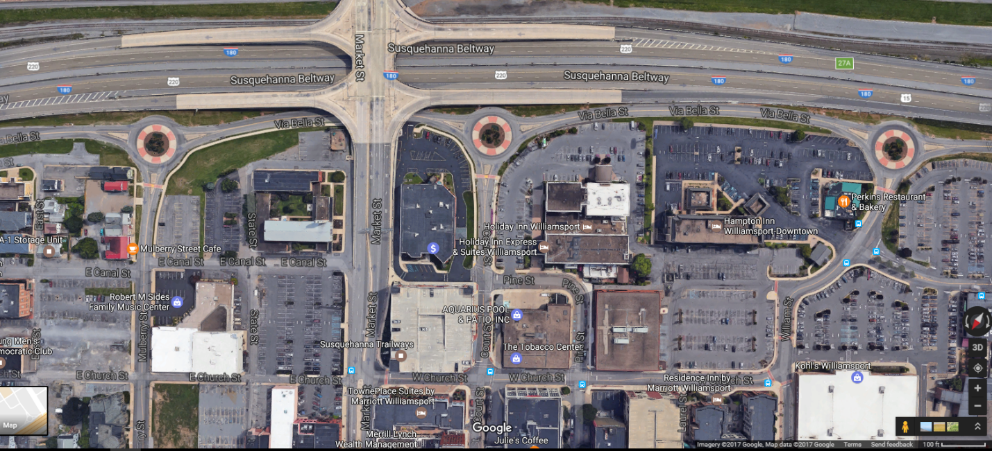

Court Street
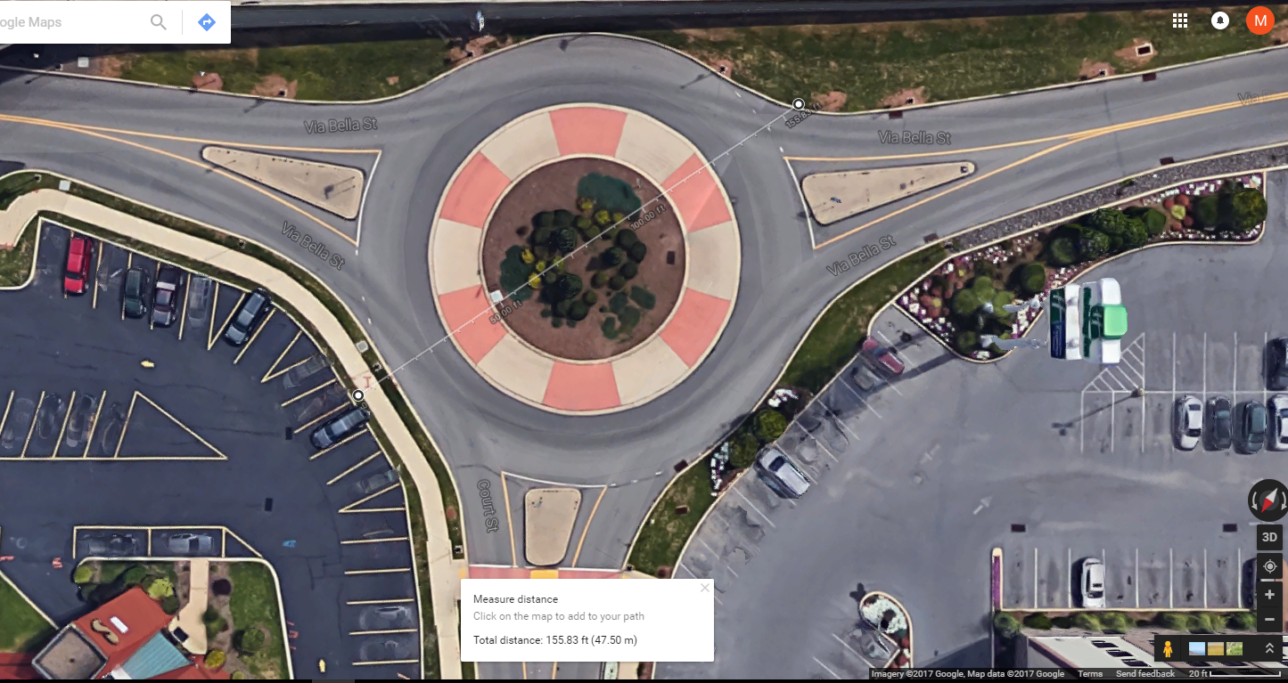

Mulberry Street
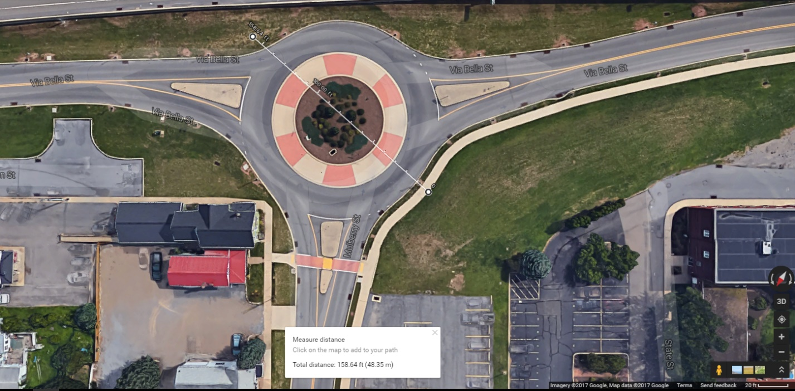

Roundabout Diameter and Composition
Despite differences in measured dimensions on Google Maps, the three roundabouts in this corridor appear to be exactly the same in terms of diameter and other geometric dimensions, e.g. truck apron width.
3-legged roundabout at Court Street and Via Bella Street with a sidewalk on one leg and no bicycle facilities with diameter of 156 feet and a width of approach of 68 feet. The diameter is measured supposing a sidewalk on a leg which was missing one. Diameter and width are measured from outside of sidewalk to outside of opposing sidewalk. Width of approach is measured at the northern crosswalk which is approximately 28 feet from the edge of the circulatory lane. Speed limit on this corridor is not posted but the roundabouts are so closely spaced that speeds likely remain low; signage for the roundabout entries advises a 15 MPH speed.
3-legged roundabout at Mulberry Street and Via Bella Street with a sidewalk on two legs and no bicycle facilities with diameter of 159 feet and a width of approach of 77 feet. The diameter is measured supposing a sidewalk on a leg which was missing one. Diameter and width are measured from outside of sidewalk to outside of opposing sidewalk. Width of approach is measured at the northern crosswalk which is approximately 32 feet from the edge of the circulatory lane. Speed limit on this corridor is not posted but the roundabouts are so closely spaced that speeds likely remain low; signage for the roundabout entries advises a 15 MPH speed.

Traffic Count Data
No traffic count data was available for this corridor.

Summary of Corridor Characteristics
Characteristics of two roundabouts from each of the studied corridors were measured and classified according to the 2000 FHWA taxonomy (FHWA, 2000). That data is listed and summarized in the table below.

Table 3 Roundabout Characteristics

Two roundabouts, those highlighted in yellow, were selected as useful examples of their type.
The first roundabout selected was from the La Jolla Boulevard corridor. This roundabout was selected because of its throughput and because it is classified as an urban compact roundabout, the smallest feasible roundabout type for this application. The FHWA (Rodegerdts L. B., 2010) claims that an urban compact is capable of handling 15,000 vehicle/day nominally without problems. With a daily throughput of 22-23,000 vehicles/day and no City concerns around congestion, this roundabout appears to be functioning well above recommended levels. This example appears to be functioning well both in terms of livability measures and traffic capacity.
The second roundabout selected was from the Maple Island corridor. All of its physical dimensions are close to the median values of the roundabouts studied, it is capable of handling larger vehicles and it is classified as an urban single lane roundabout. This class is one step above the urban compact class and can handle larger volumes of traffic. The FHWA (Rodegerdts L. B., 2010) claims 20,000 vehicles/day without problems. Traffic through this roundabout’s corridor was not high enough to assess a ceiling.

All Photos in this appendix are Courtesy of Google

